# A Student Academic Portal for Educational Institutes to be used by Students and Faculty

# *The Project report as part of Internet and Web Programming (CSE3002)*

**FINAL PROJECT (J COMPONENT) REPORT**

**Presented By: -**

**Shashank Shukla-18BCE2522**

**Mahima Gupta-18BCE2128**

**Mihir Agarwal-18BCE2526**

**Rohan Barsaiyan-18BCE2206**

**Under the guidance of**

**Prof. Nalini N**

### School of Computer Science Engineering and Programming

#### VIT, Vellore.

**CONTENTS**

1. Abstract
2. Keywords
3. Introduction
4. Related work/literature survey
5. Proposed work
6. Experiments/results
7. Conclusion /future work
8. References
9. Appendix A
10. **ABSTRACT**

Education Industry is rapidly growing and making its reach to grow great lengths and breadths. Keeping in mind the current situation with COVID-19 having greatly impacted the education/school life of the kids. Everything now Is online and thus not only teaching but the admin structure is also online.

Using modern technology and the internet to minimise work and improve productivity is a way to digital country and using technology helps to provide a smart working mechanism to enforce in educational institutes.

This is why there is a great need for a student/faculty portal system to ensure that the information/study material is passed on to the kids without any glitches. A student portal system can be of great help as it would act as a one stop where the student can login with his/her credentials and access all

information/resources ( from details about faculty to assignments to be submitted and study material provided by the teacher).

In a similar way it acts as a great help for the faculty too, as it is easy to send or pass information to each and every student without any issues. It thus reduces the manual labor of both the faculty as well as the children and makes maintaining records easier.

1. **KEYWORDS**

Student, portal, login, records, database, html, CSS, JavaScript, NodeJS, mongo dB, homepage, timetable

1. **INTRODUCTION**

In this project we have used many languages such as HTML, CSS, JS, NodeJS to create a student portal, with many added features. With everything being online today, and students uploading their friend’s assignments by just changing the name. An advance student portal as this one, is the need of the hour. As our student portal will let the teachers know if any 2 students have uploaded similar documents. In addition, it has many other features such as downloading course files for uninterrupted study, and Assignment deadline alert, so that no student can make an excuse that they forgot about the deadline. The students can also find all the required information about their faculties, including their free hours, in case they need to ask any doubts. In our student portal, the students can easily check their time table and attendance for the classes. So they know if they really need to attend the class, keeping in mind the 75% quota. All the data available to the students are personalized for them, as they have to authenticate themselves by logging in, using their email id and password.

1. **RELATED WORK/LITERATURE SURVEY**

|  |  |  |  |  |
| --- | --- | --- | --- | --- |
| **SR.**  **NO.** | **AUTHOR/ YEAR** | **TITLE** | **DESCRIPTION** | **RESULTS/ ADVANTAGES** |
| 1. | Prof. Ms. Manali R. Raut, Trupti P. Lokhande, Karishma D. Godbole  YEAR - 2019 | PCE Staff/Student Portal | PCE student portal provides an online web portal solution for academic use.  Their features help staff and students access and organize information about all aspects of paper publication data, T & P data, Alumni data and all data of alumni students  scenario of education is rapidly changing and evolving today | Man power is cut down and accurate information is provided. Information can be saved and accessed any time. Decisio take by management is aided by the data stored in the repository. so Web based system is improved |
| 2 | Angelos Rodafinos,  Filia Garivaldis,  Stephen McKenzie  YEAR 2019 | A FULLY ONLINE RESEARCH PORTAL FOR RESEARCH STUDENTS AND RESEARCHERS .  Year-2018 | It describes transferability of an integrated online research environment which is potential. it also describes its implementation, development and context.  Users are also allowed to conduct research of all kinds. | The Research Portal is now providing an online research and research teaching capacity beyond the GDPA to other online and on-campus Monash University student and staff users from the Graduate Diploma of Professional Psychology, other Psychology courses, and other Monash Schools and Faculties such as the Nursing School. Eventually it will be expanded to allow use by universities beyond Monash. The next steps in the development of the Research Portal include further refinement, personalization, and expanded implementation and dissemination of its components, possibly assisted by grants and other funding opportunities. The formation of networks and working partnerships to operate, maintain, and promote Research Portal initiatives are required to reduce operational costs, increase access, and create an impact. |
| 3 | Percia V.SECRETO,  Rhodora L. PAMULAKLAKIN  YEAR -2015 | Learners' satisfaction level with online student portal as a support system in an open and distance elearning environment (ODeL) | here they have defined online and distant learning, as the education's activities which responds to a group of learners. these groups assist in systemati realms and cognitive affective of the learning process  Main institutional systems which are involved in learner support are advising and counseling, information and administration, and teaching and tutorial. the UP Open university followes and ODel framework which stands for open and distance e-learning , here most of the learning takes place online | a study was conducted among learners which determined that their satisfaction level on OSP i.e. Online student portal of the university of Philippines was satisfactory enough. suggestions were taken and more functionaity could have been added. the study was done among people who have experienced both online and manual systems |
| 4 | Molola B.O. Ajoye, Williams E. Nwagwu  YEAR- 2018 | INFORMATION SYSTEMS USER SATISFACTION: A SURVEY OF THE POSTGRADUATE SCHOOL PORTAL, UNIVERSITY OF IBADAN, NIGERIA | This paper talks about how system quality, issues, efficiency of the portal used by the university of Ibadan. We get to know about the management and maintainence of the system. | The study talks about various aspects of the information system and predicts the satisfaction of the user and any problems the user faces when using this system of the university. |
| 5 | Kimeshan Naidoo,  Dr Graham Roberts  Year-2016 | A web application connecting high school applicants to enrolled university students. | This project is about building a web application that connects high school students to current university students. The key challenge was developing an application that would attract high school teenagers and students by possessing a rich variety of features while providing a practical and easy to use platform that enables high school students to chat online with university students. | While there are vast amounts of research and best practices, completing and evaluating a software project in entirety is not a trivial task. Reflecting on this project, it is clear that regardless of the amount of analysis and design conducted for a software project, there will almost always be unexpected challenges and changes that arise. Hence, the Agile approach that embraces change was validated by this project and the author understands why Agile has reached such a high degree of popularity in the software engineering community. |
| 6 | Ruofan Ding, Thomas Grimshaw, Penelope Over  Year-2015 | HackBox Admin Portal | This project was made for the Microsoft Hackathon tool. This project is an Admin portal that allows the admin to keep a check on the contestants. It helps them to view, modify any changes in the details of the participant, their projects etc. | Our research showed that the tools to manage a hackathon were few. The database for the hackathon needs to be most efficient to ensure that the latest updates are being stored in the dayabase. This portal will help the admins to keep a close eye on the new/existing developments. |
| 7 | ADEDAYO BABAFEMI ALAO,  Associate Professor Dai Yu,  Professor Shi Gang  Year-2016 | Design and Implementation of SaaS Based School Management System | This chapter explains in detail about the research background, problem statement, the objective, a little to the possibility that is cloud computing and also Software as a Service (SaaS) platform and its benefits, scope and the thesis organization of this project for this system. | This introduces cloud computing, the different aspects of cloud computing, software as a service, cloud database, Microsoft Azure services, Azure SQL database and elastic pool databases and finally school management system. Finally the design and the implementation of a SaaS based School management system was described. Also this system uses the latest technologies like NodeJs, Microsoft Azure services, HTML, JavaScript and a lot more. |
| 8 | Feras Qawasmeh , Abdulhadi Tahir,Haris Tresnjo,Amina Zilic,, Jamaludin Ibrahim  Year- 2017 | The student portal performance- comparative study (GSM-IIUM) | This paper talks about three very different aspects that are often confused to be the same: knowledge, data and information. People often misunderstand these three to be the same. This paper says that information is of absolutely no use if the people don’t understand it in the right sense. | The quality of the way in which information is shared amongst the students plays a very important role in how the students understand it. Thus it is important to create a portal which is interactive and attractive to ensure the desired interest by the students. |
|  |  |  |  |  |

1. **PROPOSED WORK**

The website offers students and faculty the ability to connect in terms of the academic requirements , online via a web application, called the student/faculty academic portal. This would provide services like checking and updating attendance ,getting the study material from the faculties , uploading assigments within the prescribed dates etc. This resolves all the manual process drawbacks and reduces the room for error, improves the productivity and speeds up the work that needs to be done. On the side of college management, a person can easilty see the details of students than print the student details on paper.

The database maintained by the university will ensure thatvery student and faculty has a unique username and password for loggin in and accessing their account. A ll data stored regarding the student will be validated by the servers from the college . This method also leads to ensuring integrity of data and coherence.

We have ensured to provide all the basic functionalities that a student portal must have to ensure smooth function of the system.

There will be two kinds of Login :-

1. Student Login
2. Teacher Login

**STUDENT LOGIN** : The student login as the name suggests will be used by the students for accessing and submitting their works. The following are the functionalities included in the student login :-

* **Home Page** : The home page provides all the information regarding the student which includes his personal details, academic details, hostel details etc. The homepage will also be a host for the latest news from the college which will be shown using the ASIDE feature from HTML. This would include updates about the college, new announcements, assignment deadlines etc. The homepage will also talk about the activities related to clubs and chapters.

All this information will be updated dynamically as and when required.

* **Time Table**: This page shall talk about the timetable of the student.
* **Faculty Info** : This page will provide the student about information regarding faculties (i.e. their name, contact number, cabin number, free hours etc) and student can make use of this info to get their doubts cleared.
* **Course Page**: This page will provide the students with the study material that the faculty has used for teaching. The students can access this data at any moment and thus use it for better understanding at a later time after the class.
* **Submit Assignment**: This page will allow the student to submit their assignment well within the due date. Once the due date shall pass the student will not be allowed to submit his/her works.

**FACULTY LOGIN**: This login will only be used by the faculty members of the educational institute. The following are the functionalities included in the teacher login :-

* **Add Details of a Student**: This option will be given to the faculty to update/modify/enter/delete the data that was visible on the homepage of the student. This option is given only to the faculties to ensure that the data entered and maintained in the database is legitimate.
* **PLAGIARISM CHECKER**: This is the novelty of our project The students will be allowed to upload assignments from their login. The teachers will have the privilege to check plagiarism between thedocuments uploaded to ensure thatstudents do not copy the assignment. Plagarism will be checked among the contents uploaded by students.
* We have used the concept implemented by search engine crawlers to store indexes of words of web pages called the tf-idf approach.
* We will store indexes of words, their location in document and document id.
* After making such inverted index we will compare location of each word and their document id.
* Various similarity measures can be used for result.

**Technology Used:**

* **TF-IDF**- This technology/methodology has been used to implement the plagiarism checker in the project. This is a very known concept used and implemented by almost all search engine crawlers these days to store indexes of words in the web pages.We will store the indexes of words and their location in the document and their document id in a table. We will then construct an inverted index for the same. This would then be repeated for the second document , with which we will compare the first one. After making such inverted index we will compare location of each word and their document id in both the tables. Then,Various similarity measures can be used for presenting the final output, the plagiarism percentage.
* **HTML** - HTML is a language that is used alone to build a static webpage. HTML is an abbreviation for HyperText Markup Language.HTML is the basic framework of any website, thus without its knowledge creating a website is impossible. If we just build our website using html, we can not add many of the powerful web page properties for the effective and interactive making of a web page. Different frameworks are used, like CSS for beautification , JS , NODEJS for dynamic attributed etc. So we use these technology to enable and optimise our web sites efficiency and engagability. And to make our web app dynamic Java script,nodejs is used by us.
* **CSS** - The CSS stands for "Cascading Style Sheet." As the name suggests this used to format and style the online pages. You can Use this for styling text , tables and other components of the Page which could only be previously specified in an HTML page. It aims to minimise the time used for the tedious and tough job of presenting the web app in a beautiful way.
* **JAVASCRIPT** - JavaScript is a text-based, client- and server-side programming language that helps you to create web sites which are interactive, i.e the user can interact with it. JavaScript offers web pages with interactive features while HTML and CSS are languages that offer web pages structure and design. The various features that js provides are dropping down a menu on a click, making a carousel of images move, etc.
* **NODE JS** - Node js is used to create the backbone structure i.e. the backend of the web application. The server side part of the application is developed using nodejs. Node.js applications are written in JavaScript, and can be run within the Node.js runtime on OS X, Microsoft Windows, and Linux. Nodejs is preferred over its counter parts because it is and asynchronous approach and is non blocking in nature. It is extremely fast and highly scalable.
* **MONGO DB** – From the mid 2000s mongodb has been the go-to approach for developers as a database. Mongo DB works as a database and stores information gathered from the respective web page. It is a document oriented NoSQL Database system. It is highly popular for its ability to store huge amounts of data efficiently and maintain the integrity and security of the same. Rather than using the traditional method of using tables and rows and coloumns to store data, Mongo db uses a more futuristic approach. It divided data to key value pairs and thus uses collections and documents to store data.c

1. **EXPERIMENT/RESULTS**

**Main page-**

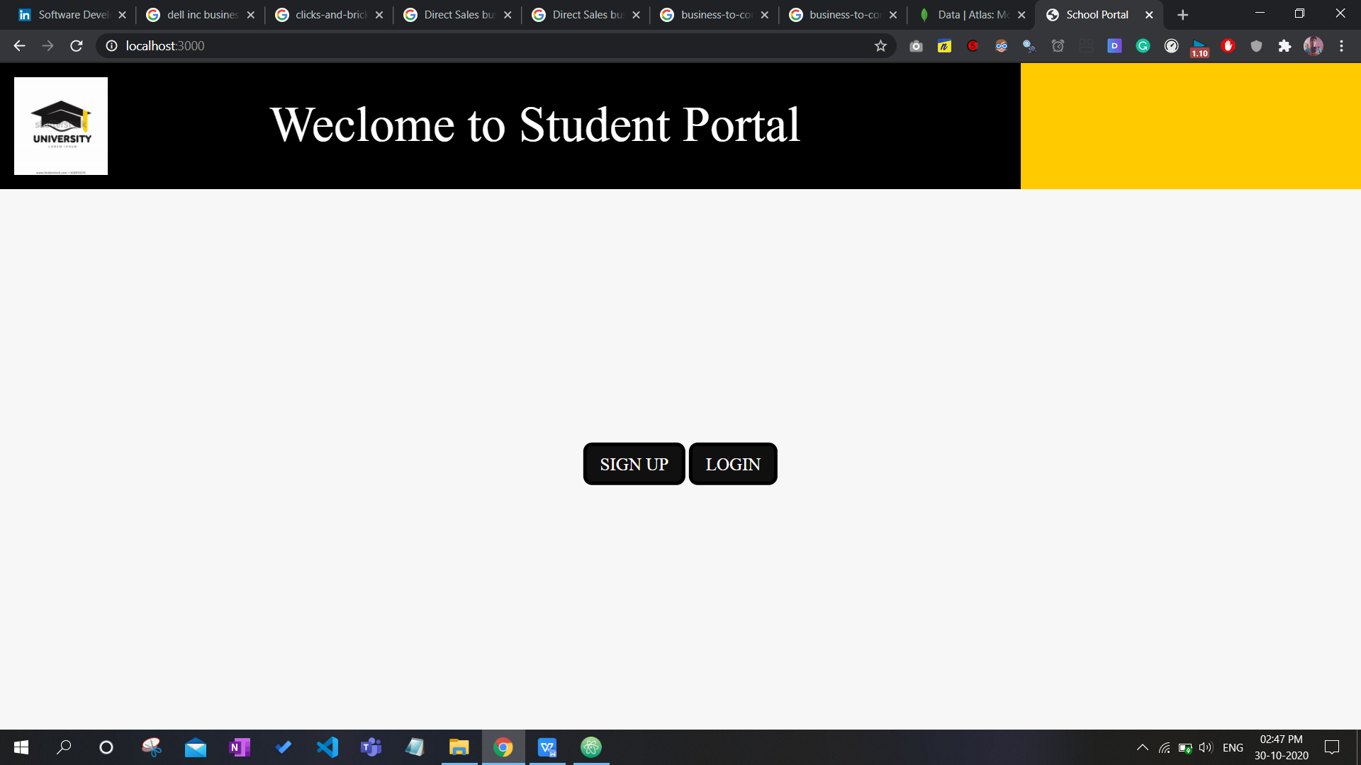

**Sign up page-**

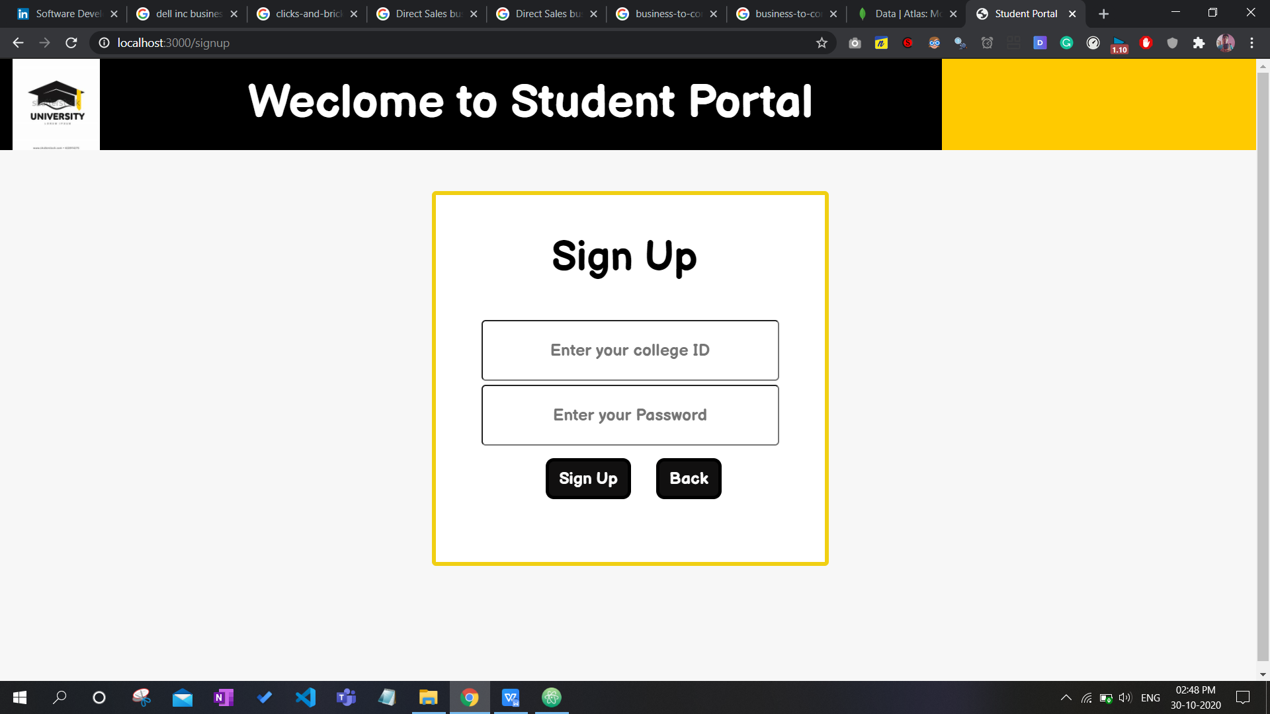

**User Login page-**

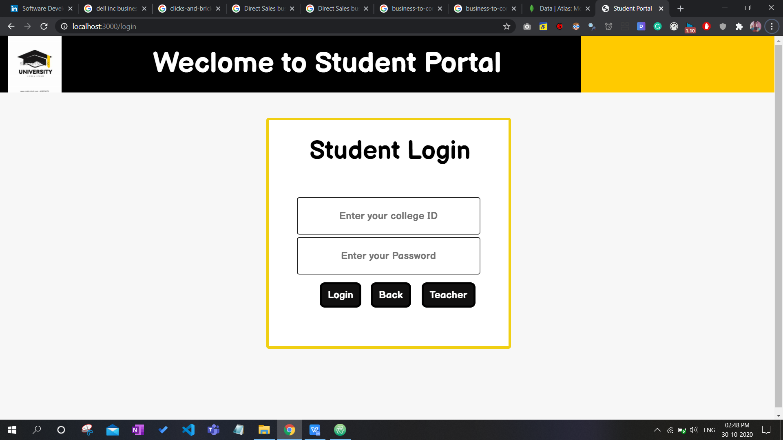

**Teacher Login-**

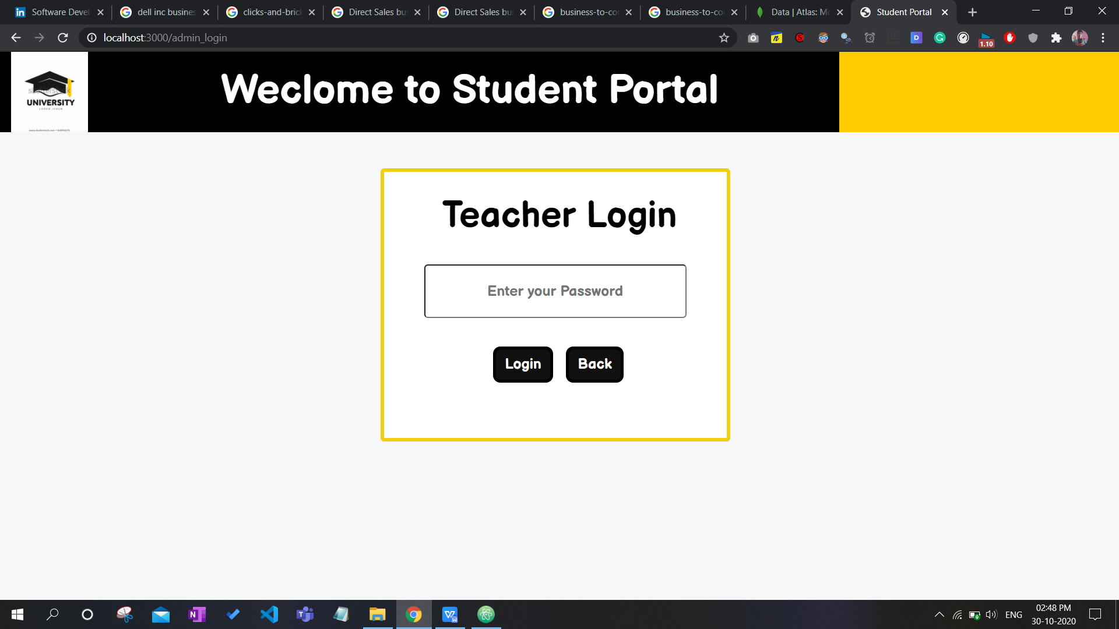

**Login from account of 1 user-**

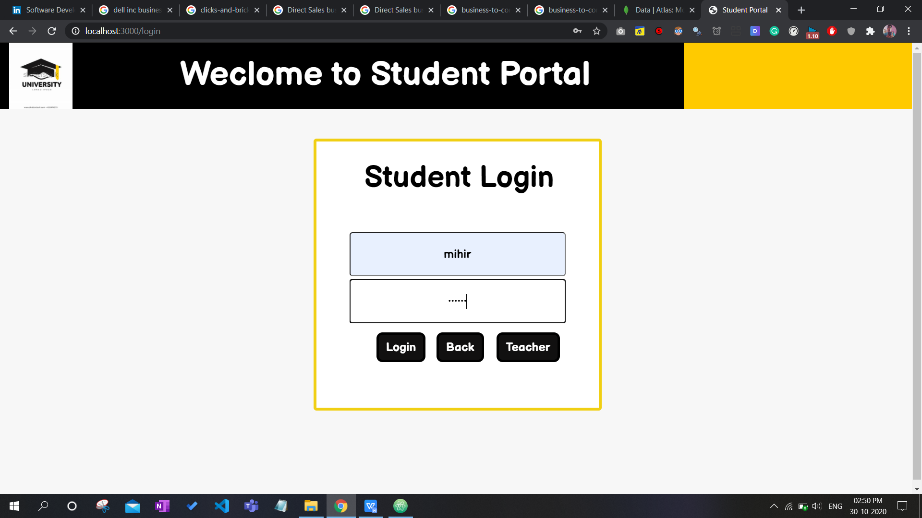

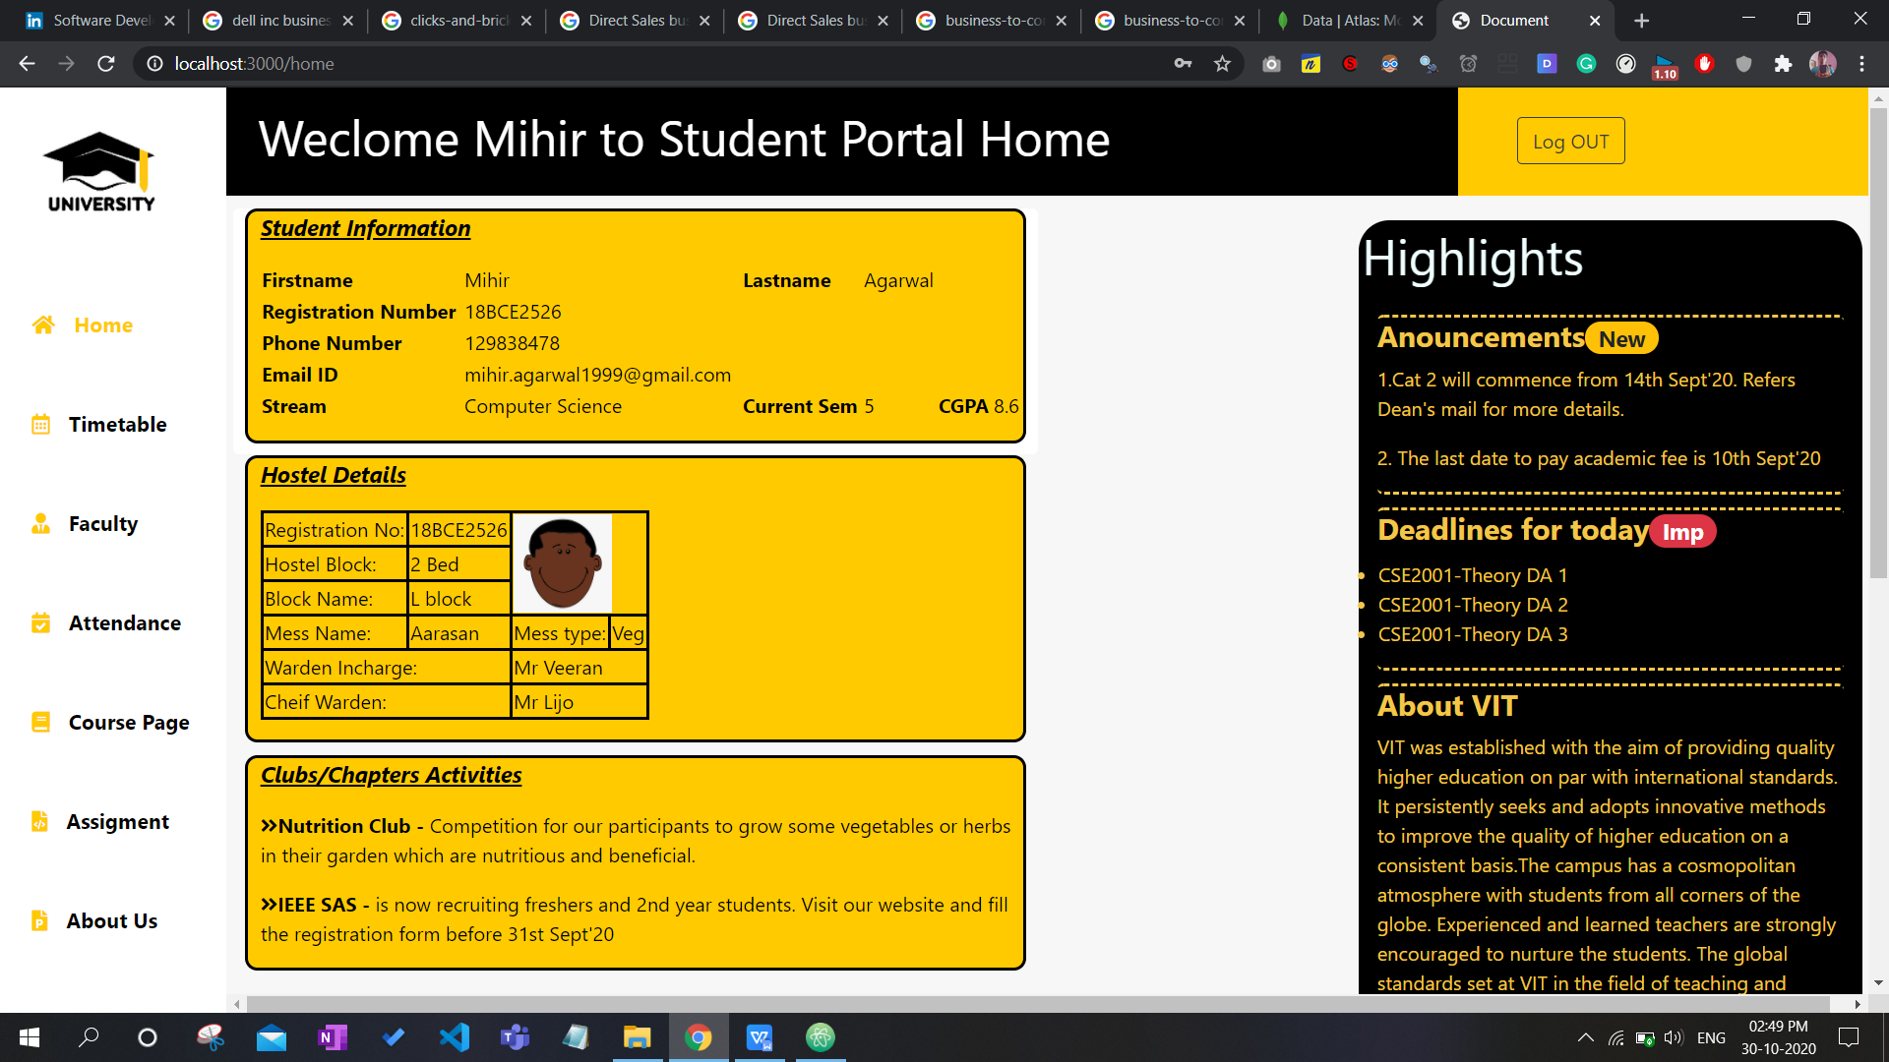

**Login from account of 2 user-**

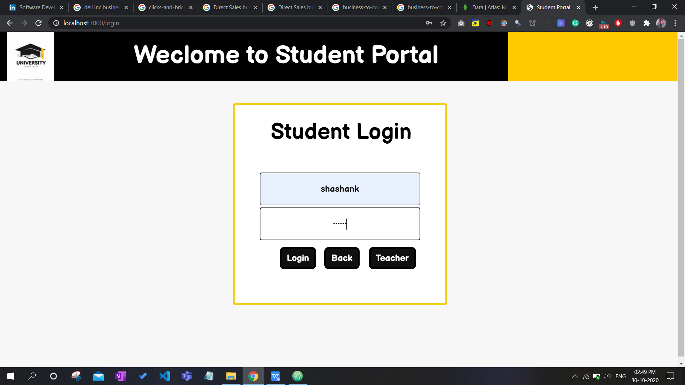

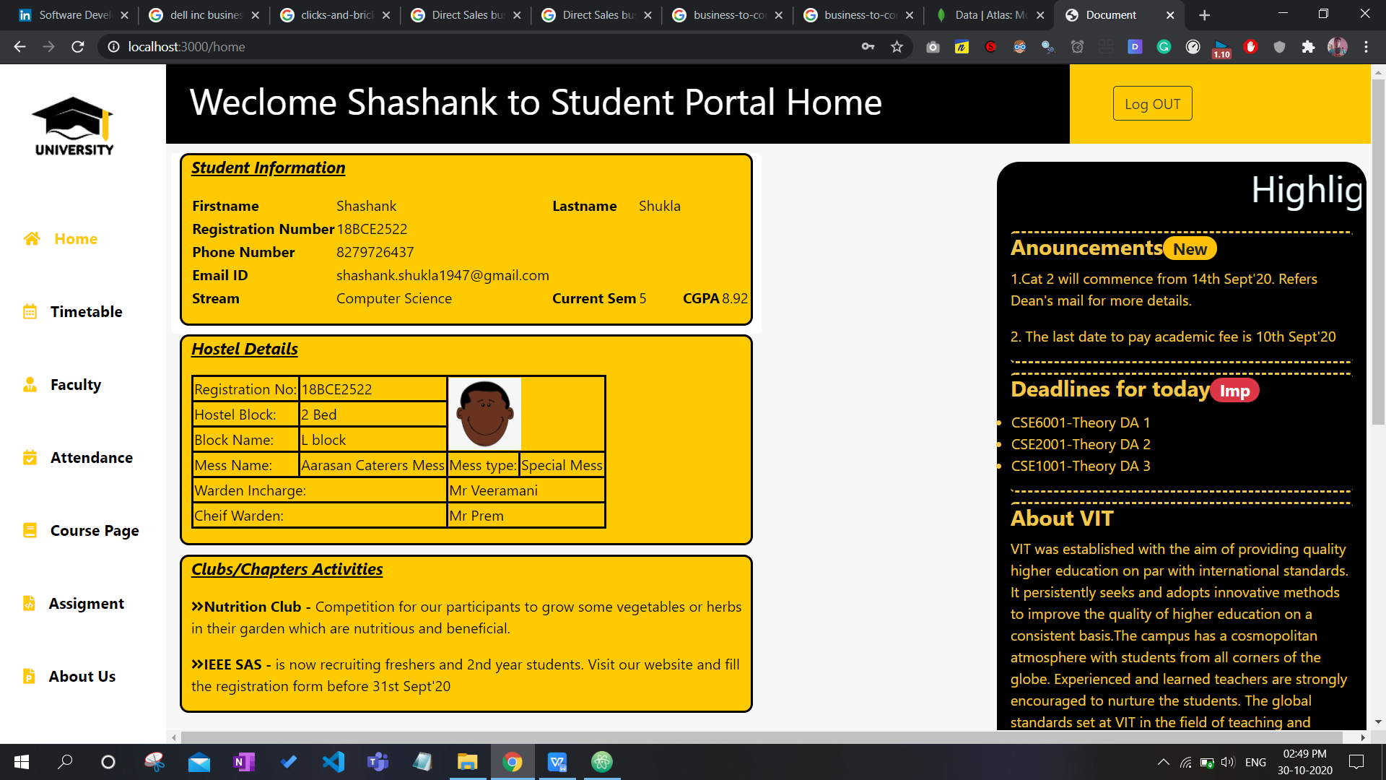

**All remaining pages-**

**Time Table –**

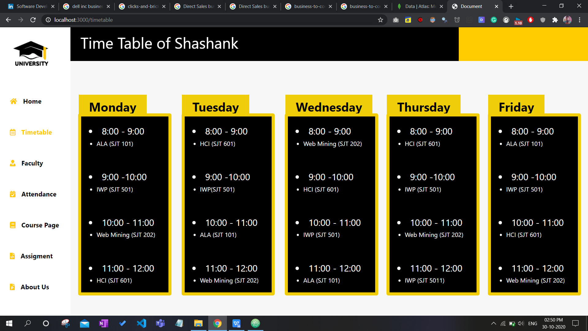

**Faculty Info**

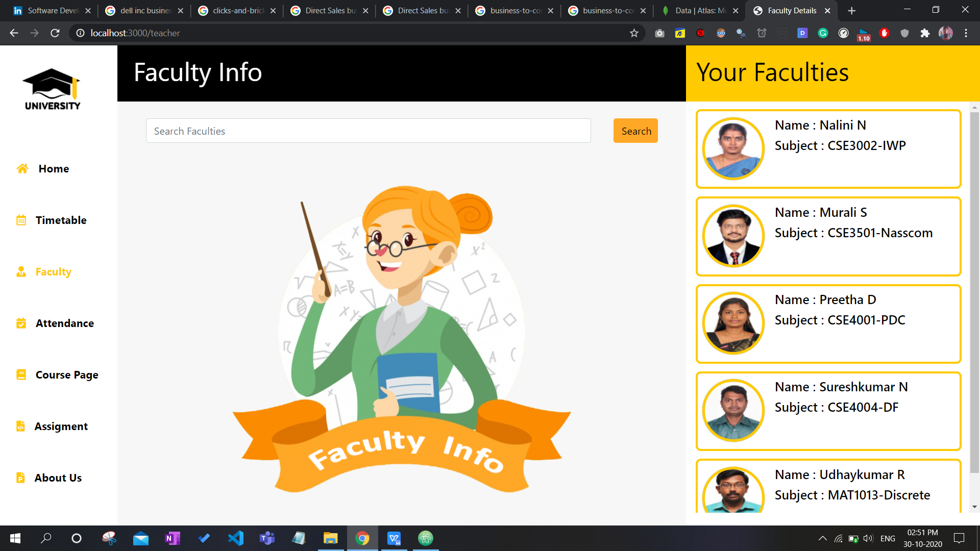

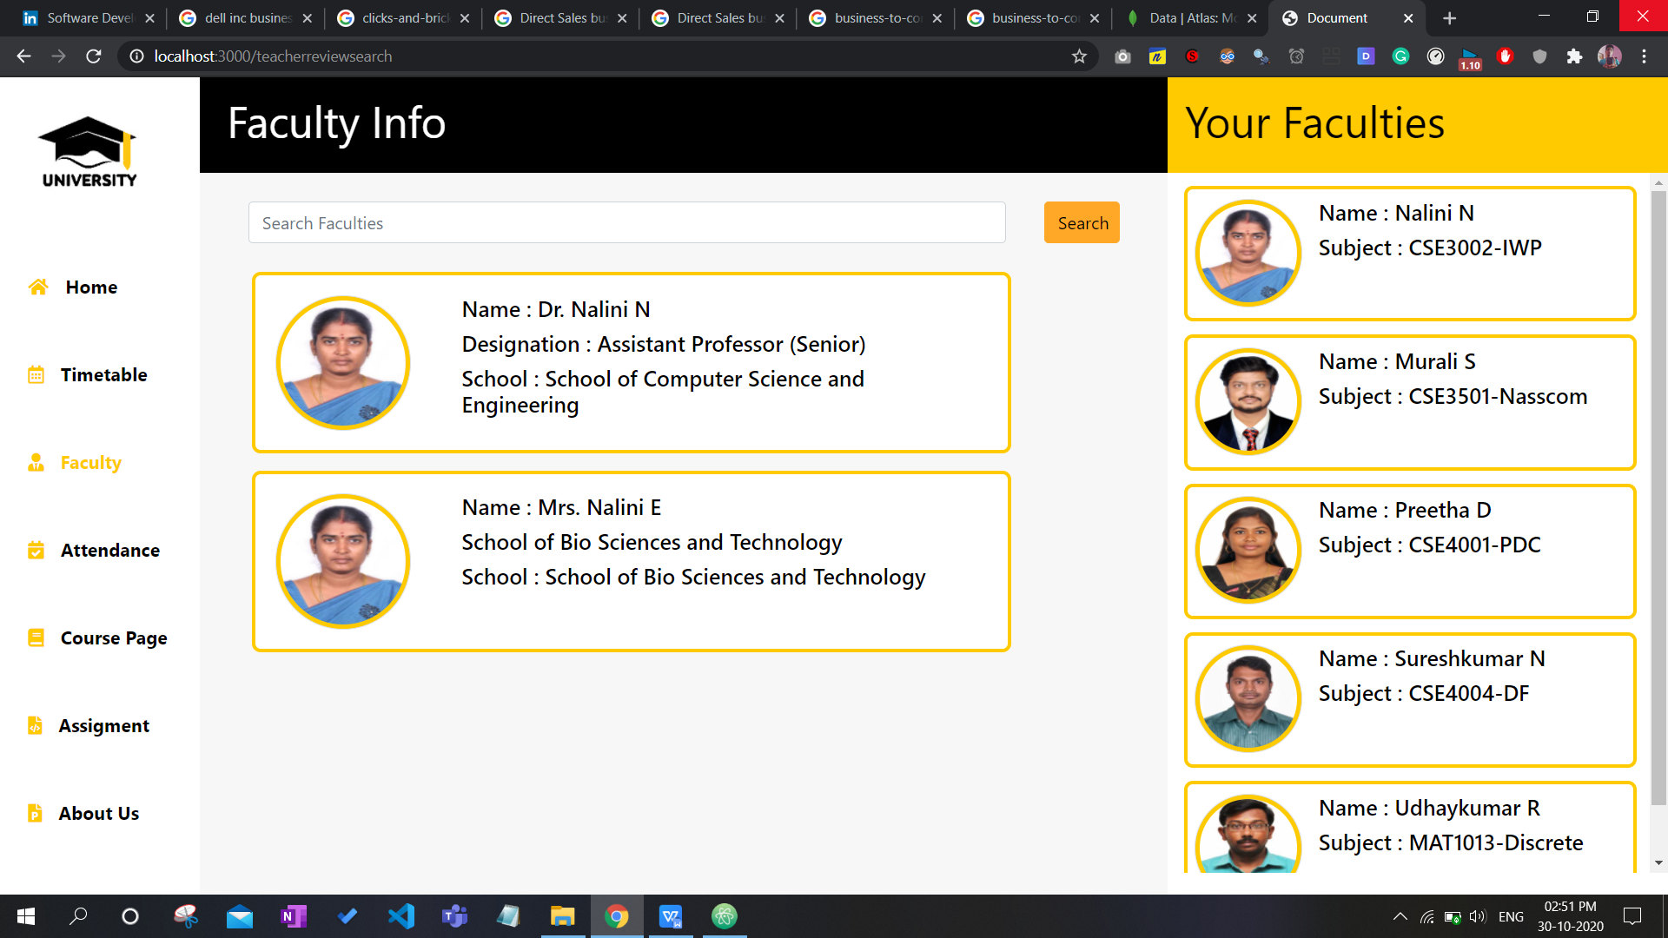

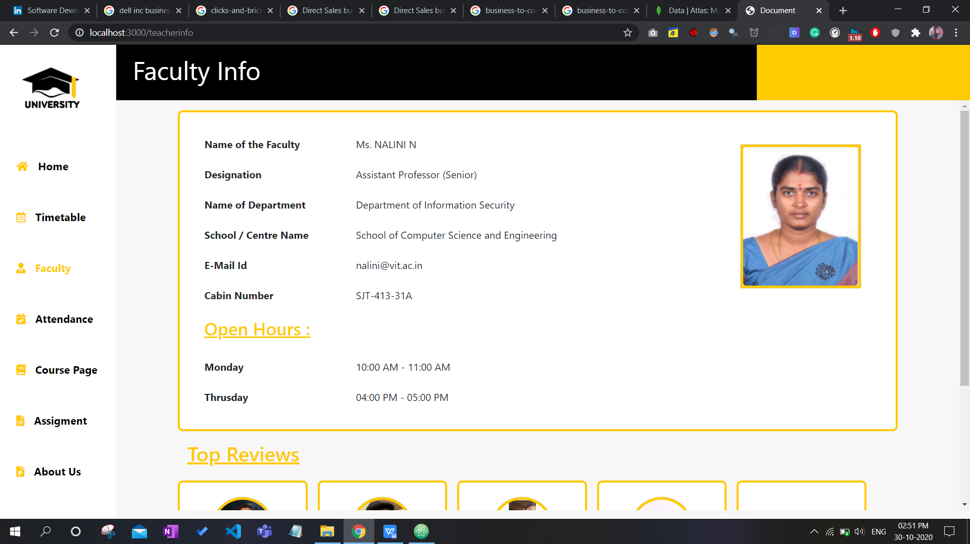

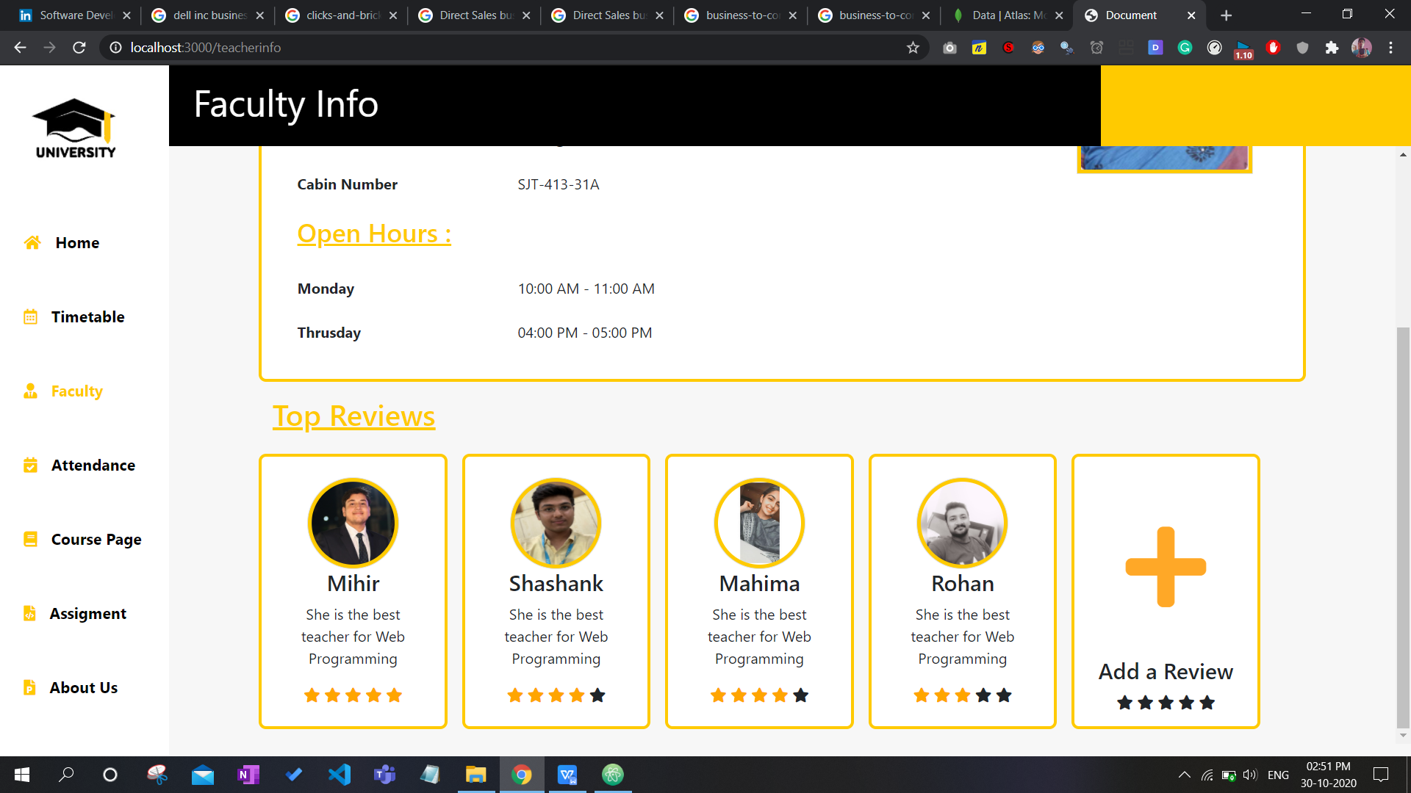

**Attendance**

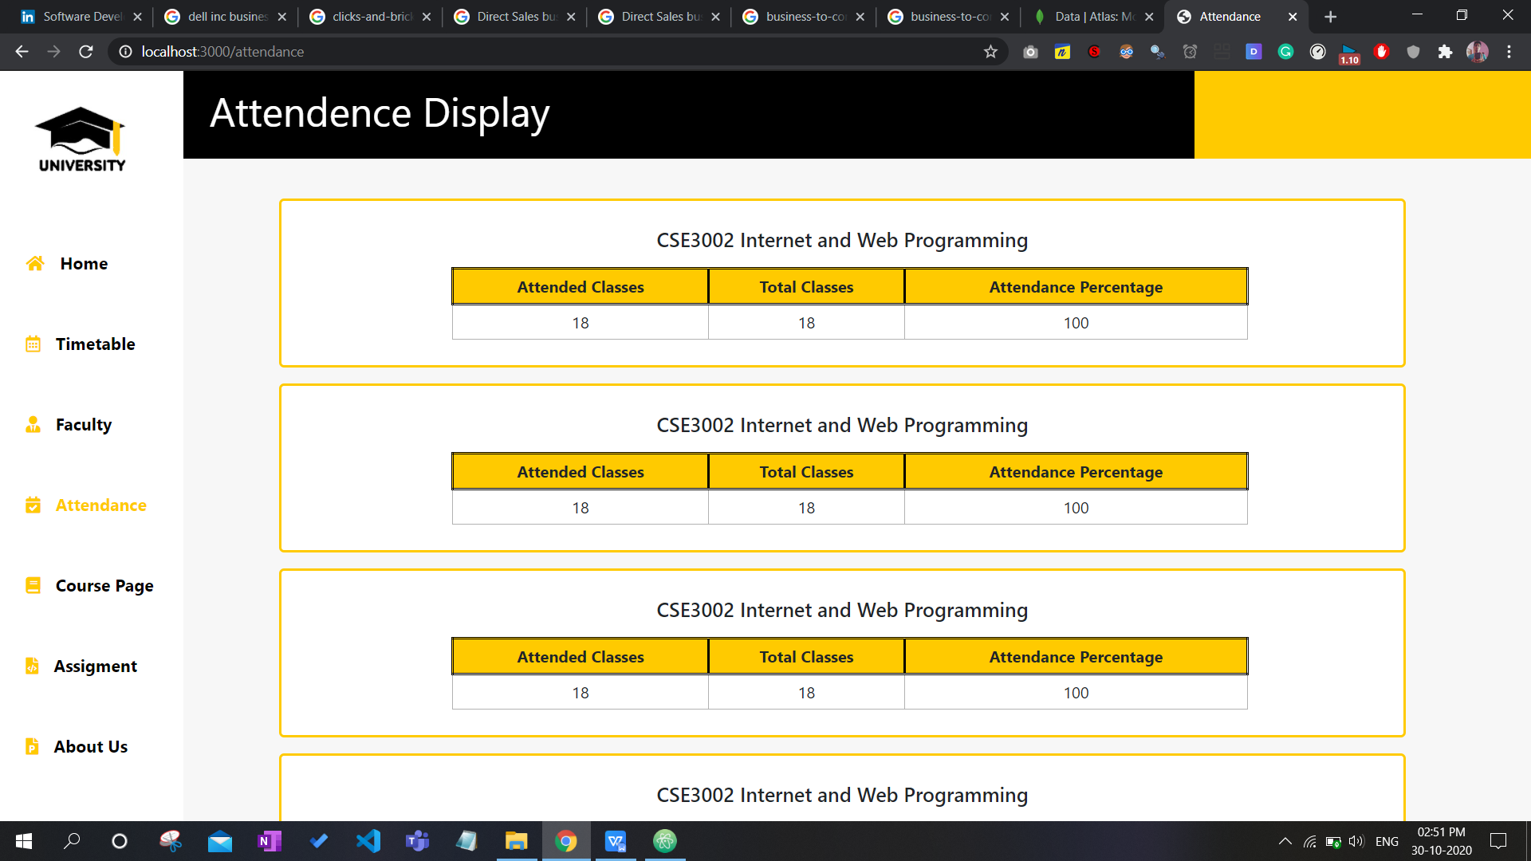

**Course Page**

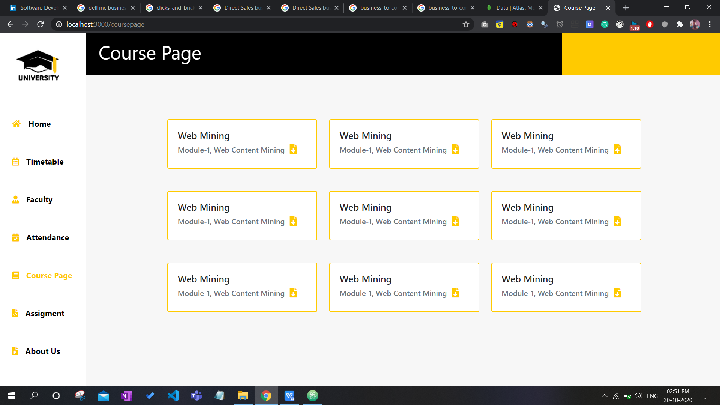

**Assignments**

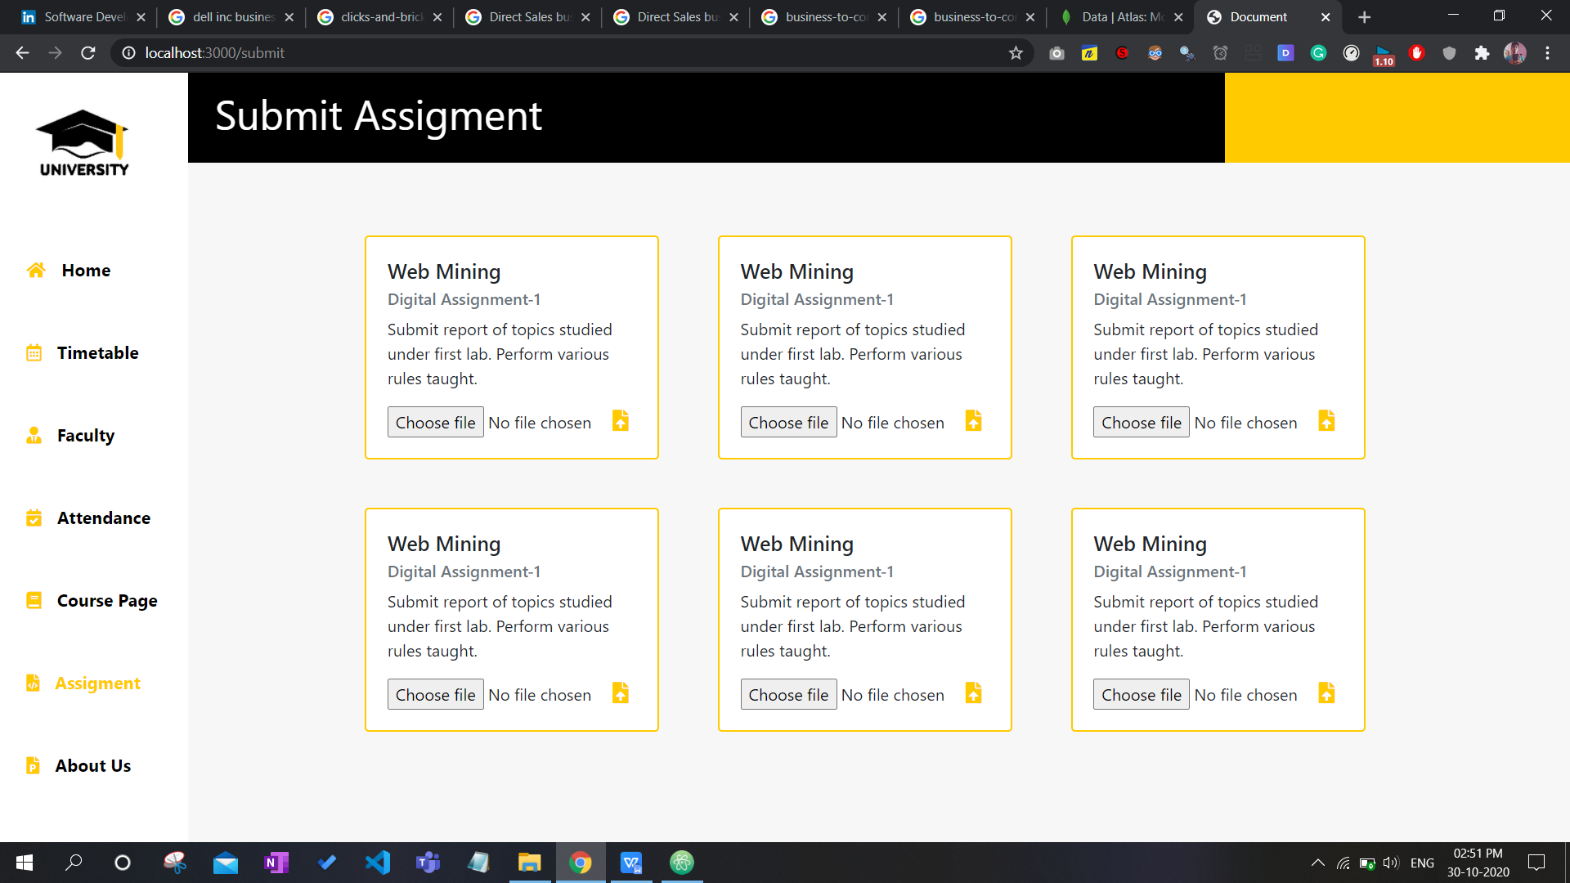

**About Developers**

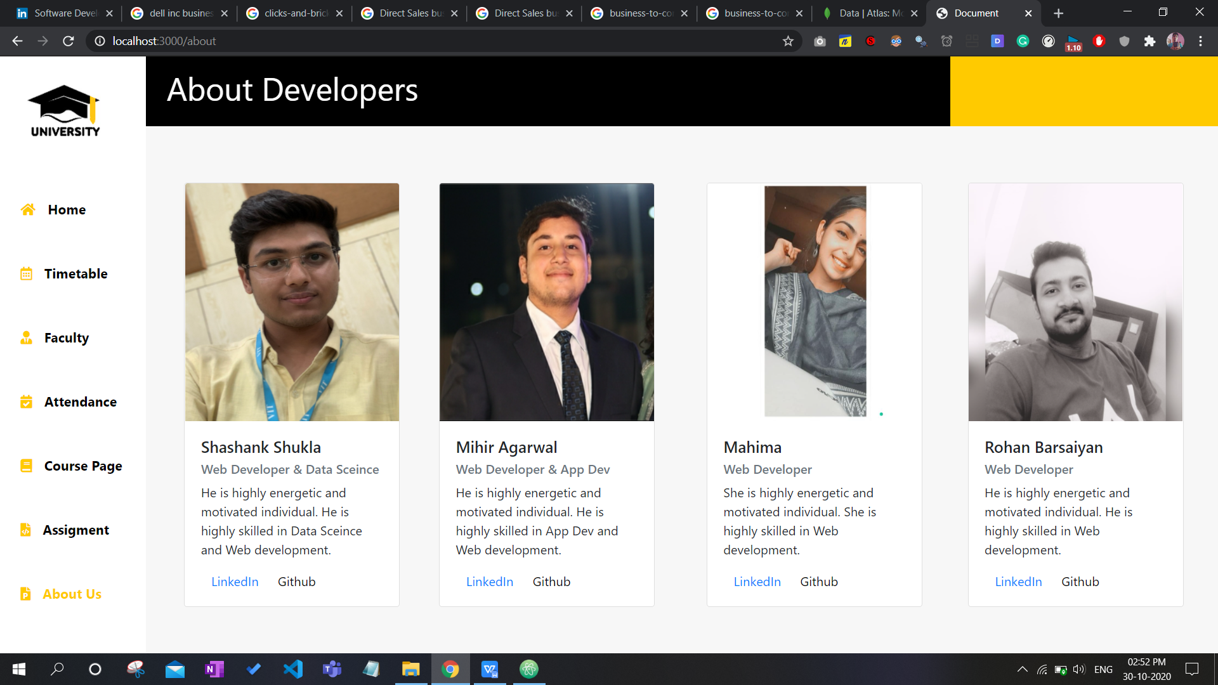

**Plagiarism info for the faculty**

**File upload from user 1-**

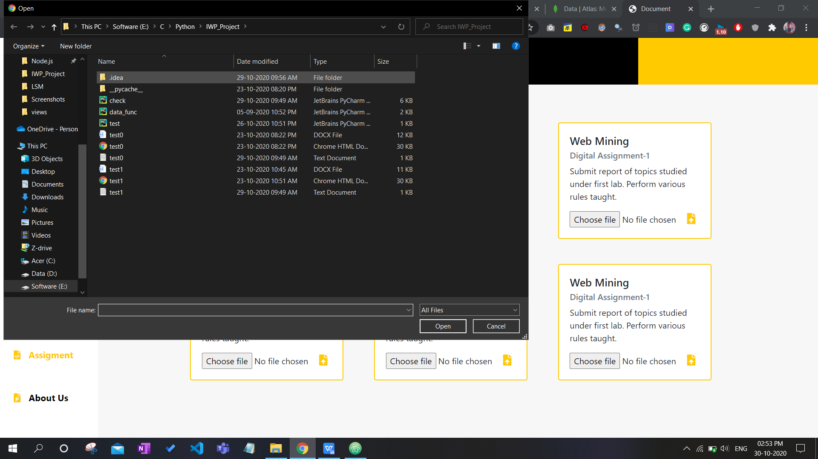

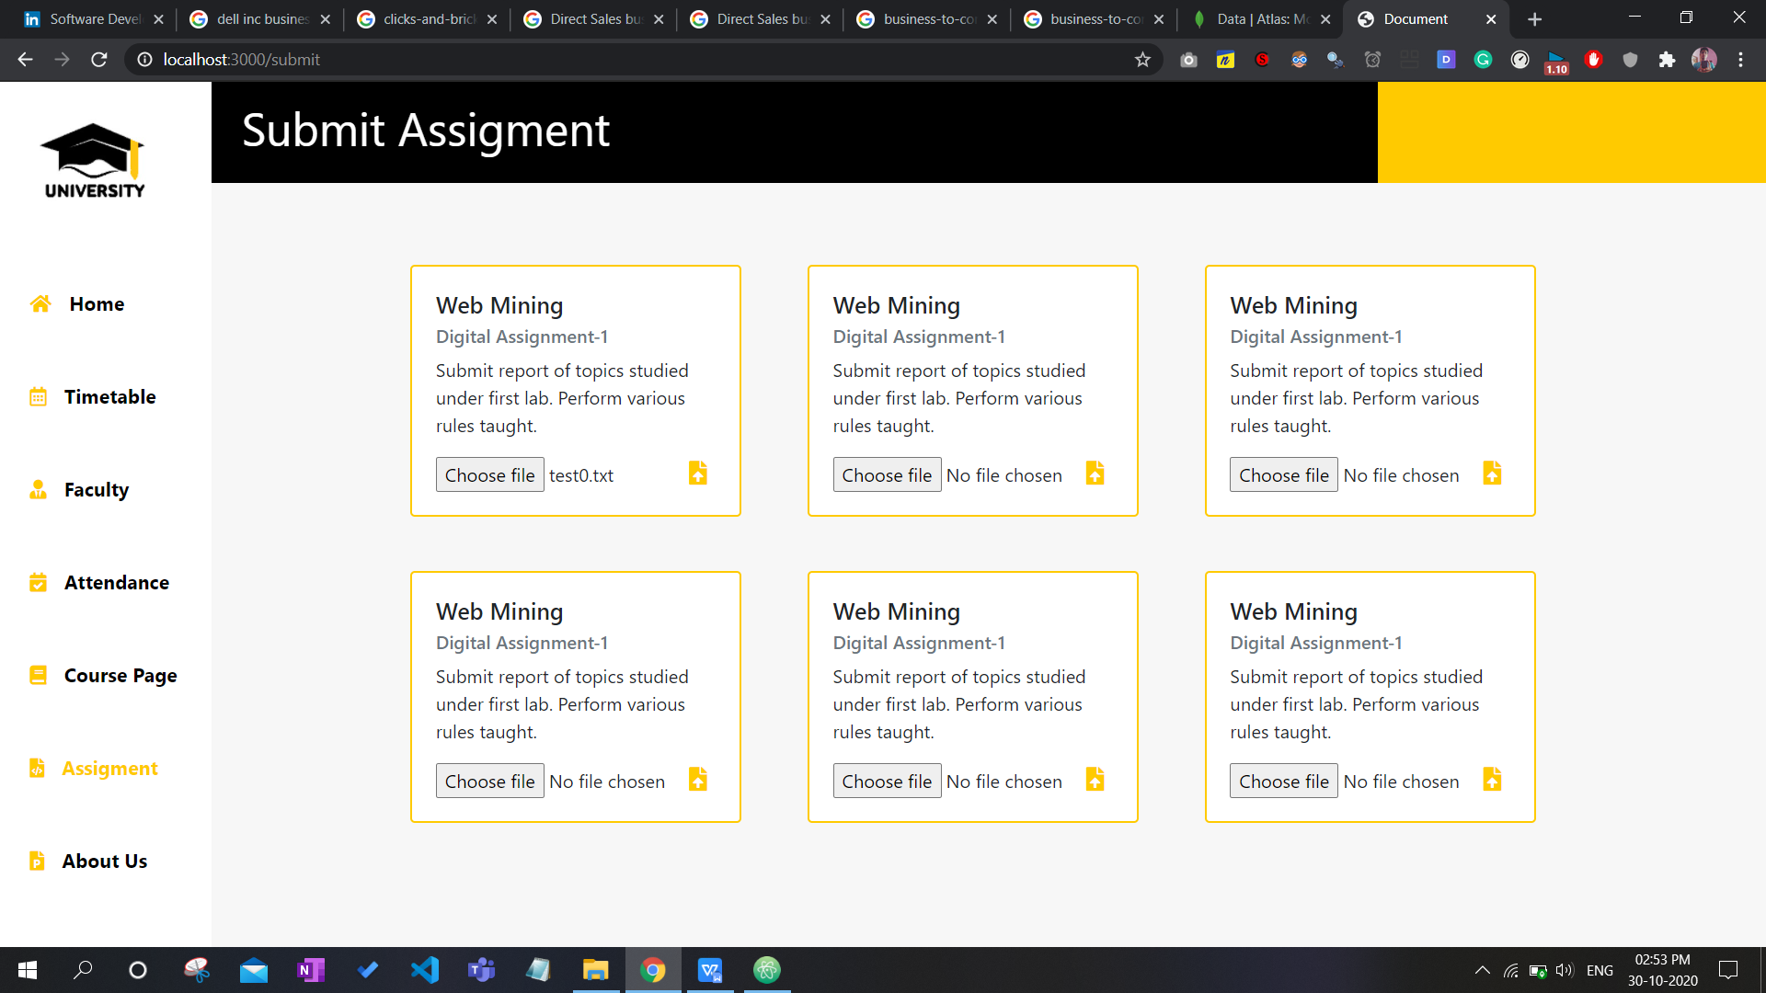

**File upload from user 2-**

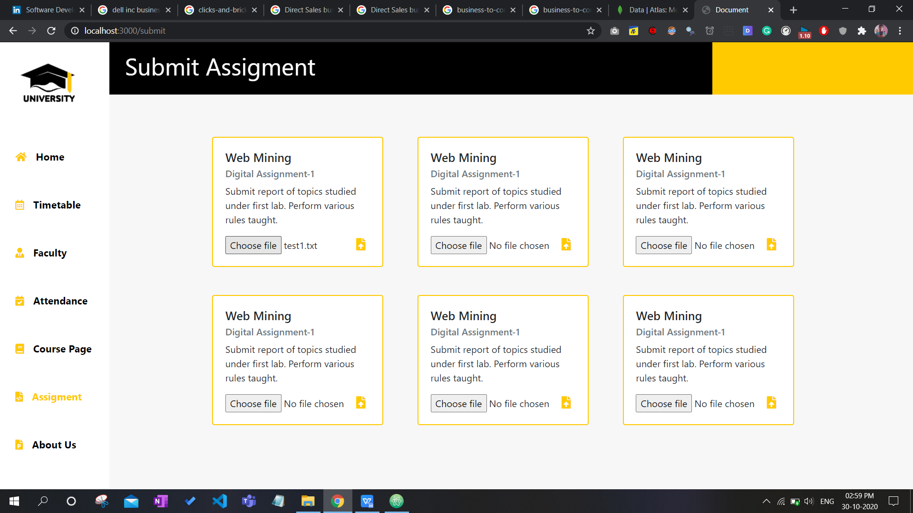

**Both the files in database, uploaded as chunks-**

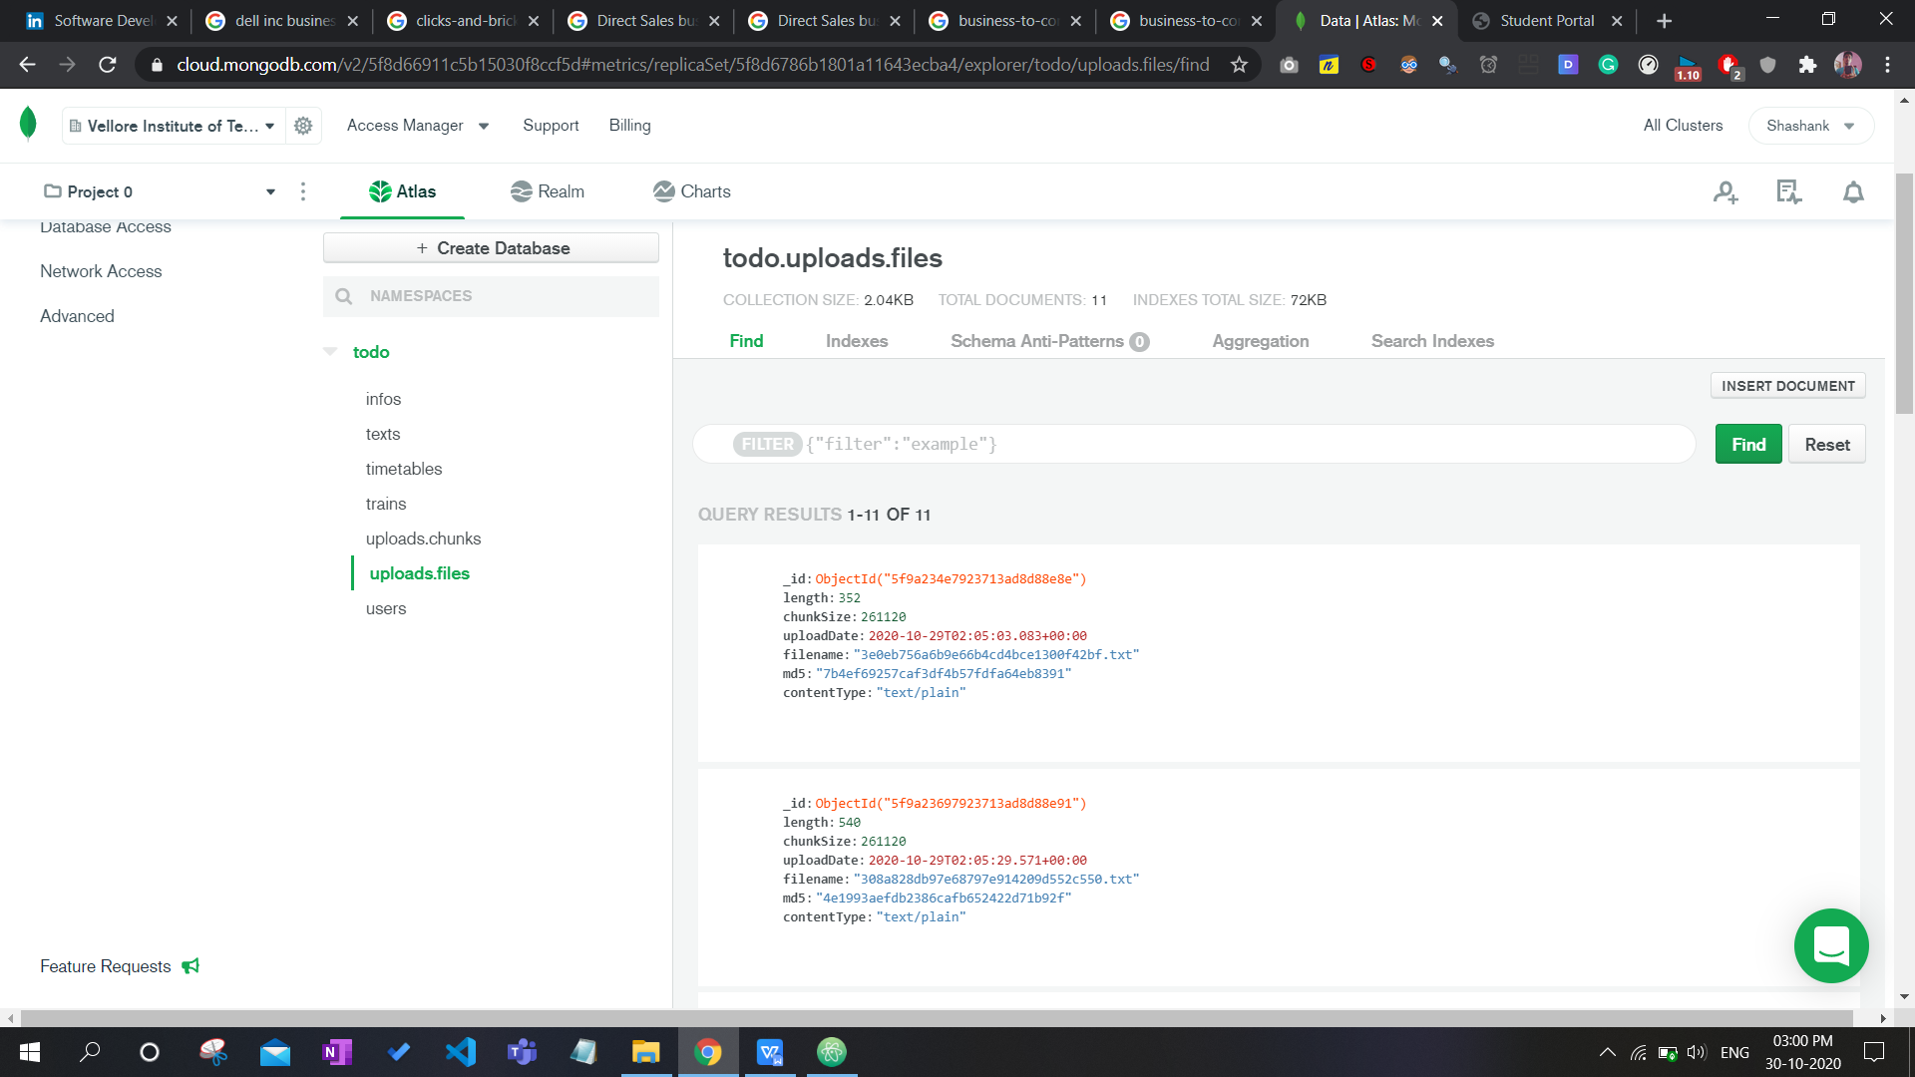

**To check plagiarism from teacher login-**

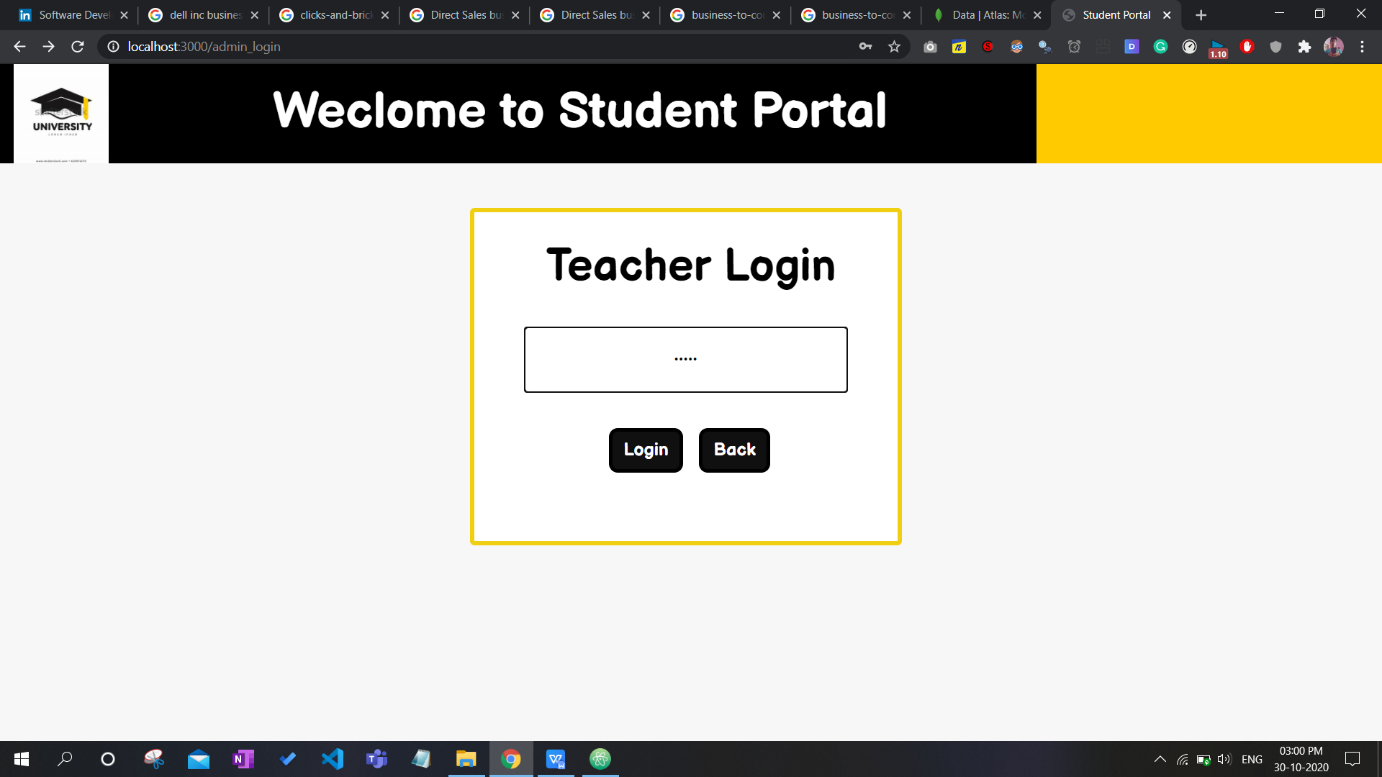

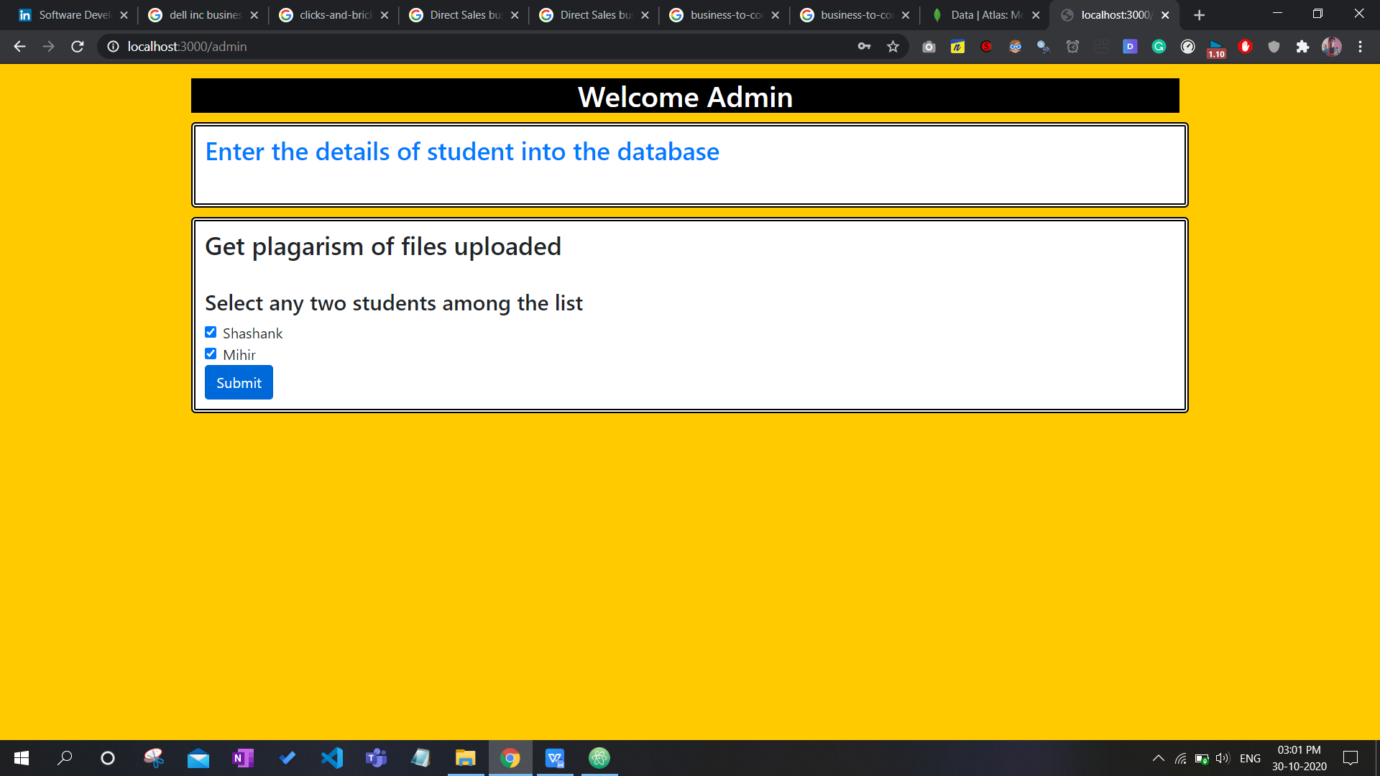

**Final output of plagiarism displayed on web page-**

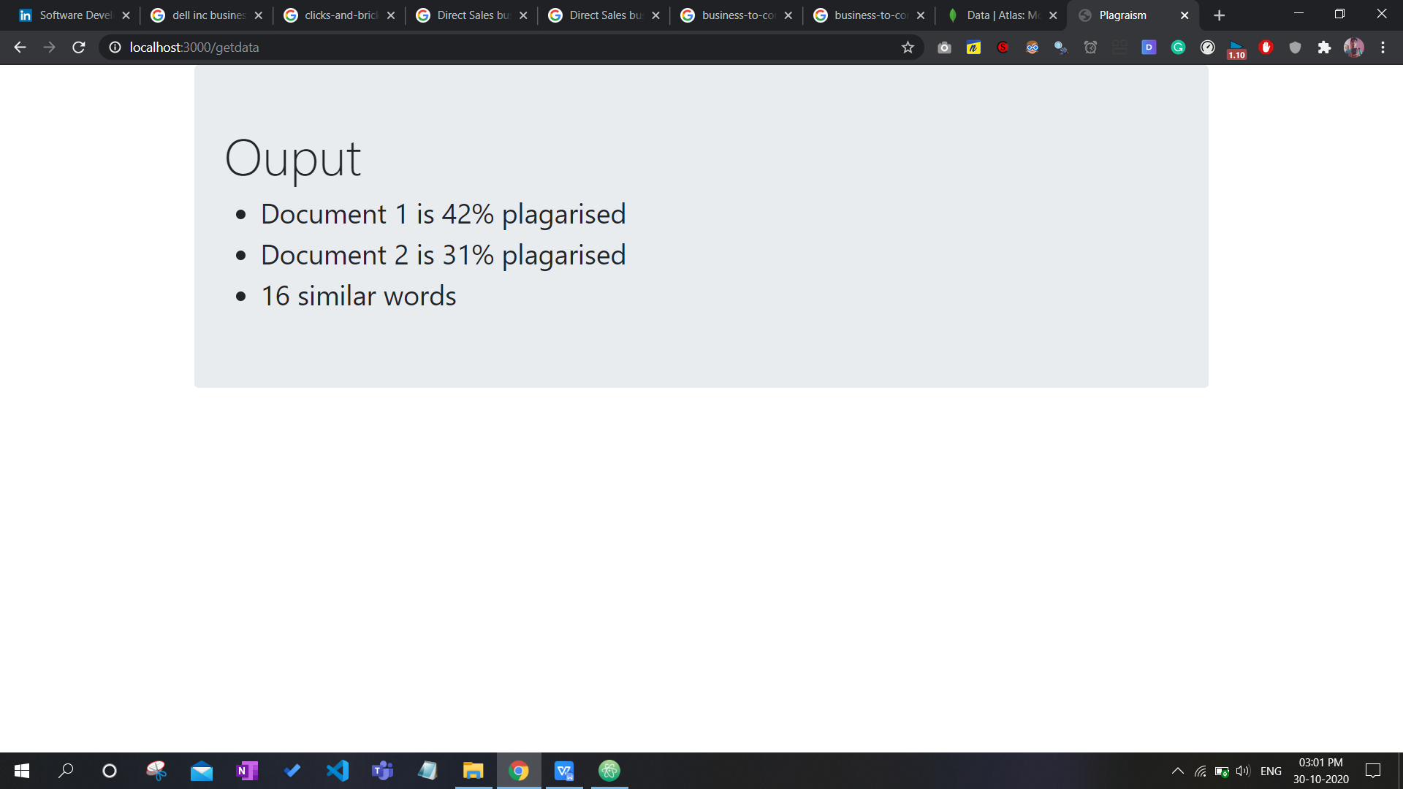

**Plagiarism on online website for the same 2 documents uploaded-**

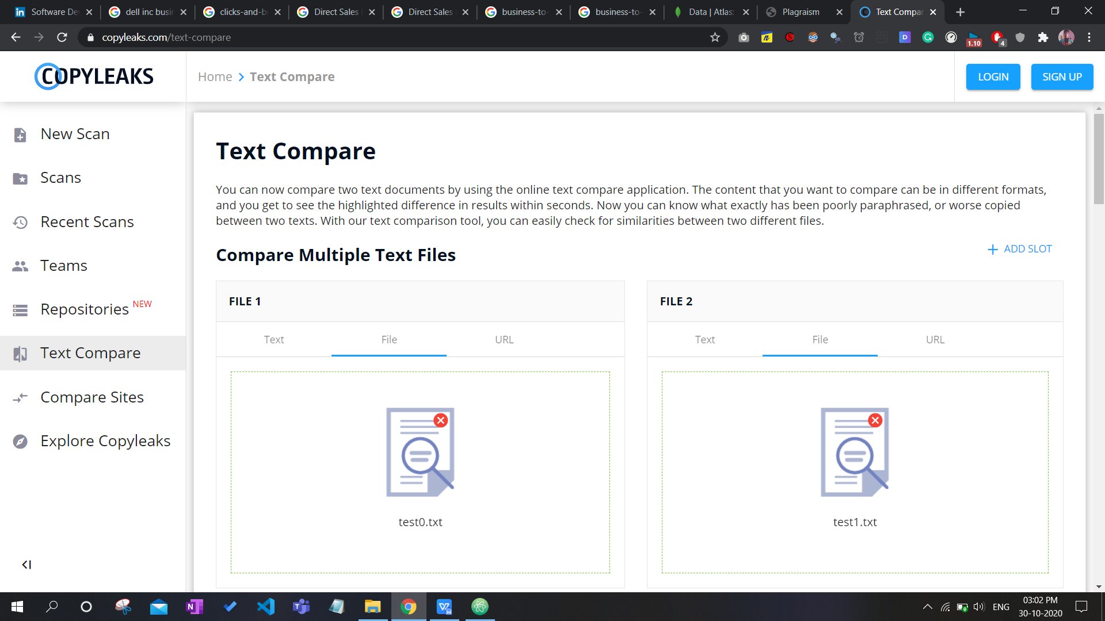

**Output-**

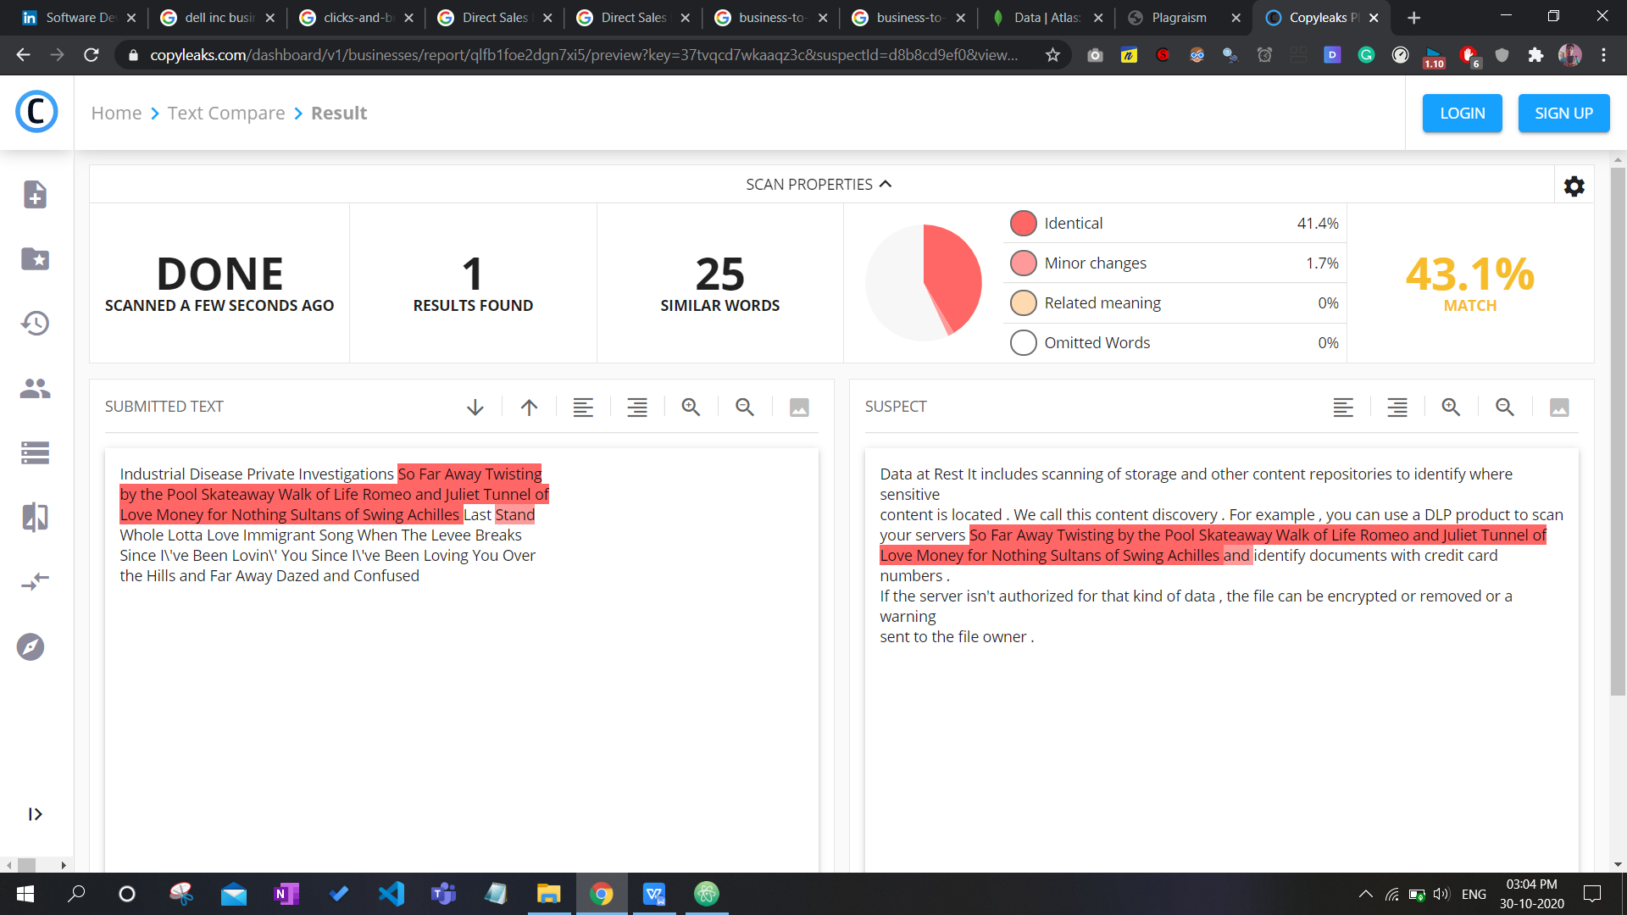

We can see result is almost same, its 25 in website as they are comparing stop words like “the”, “or”, “and” also but we have removed them compared only core words hence its actually 16.

**Registering new user-**

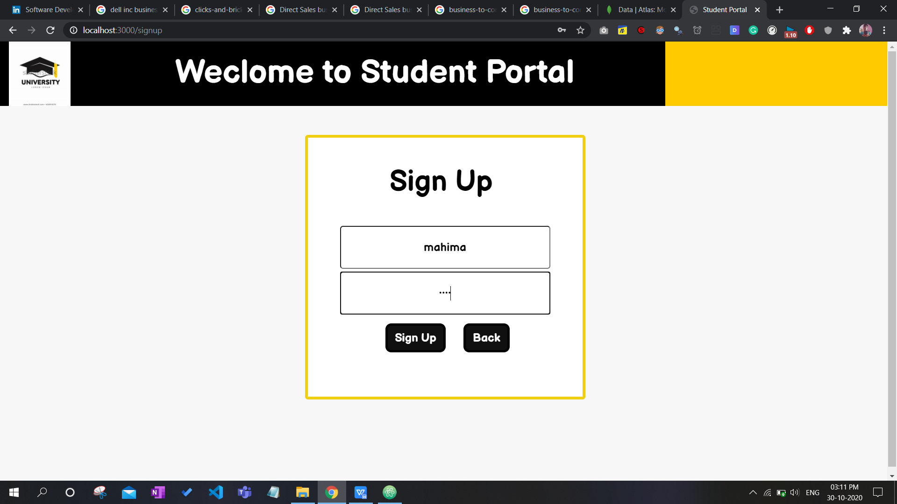

**Details gets added into database-**

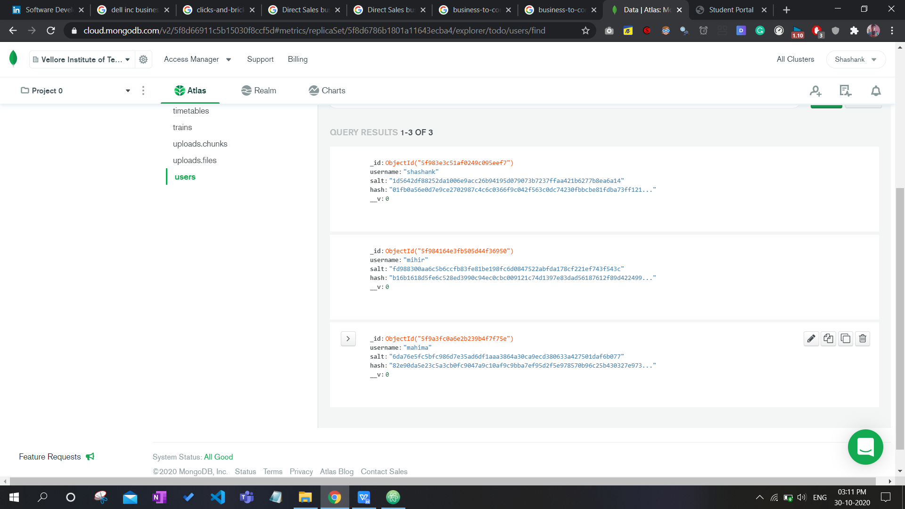

**No information for new user-**

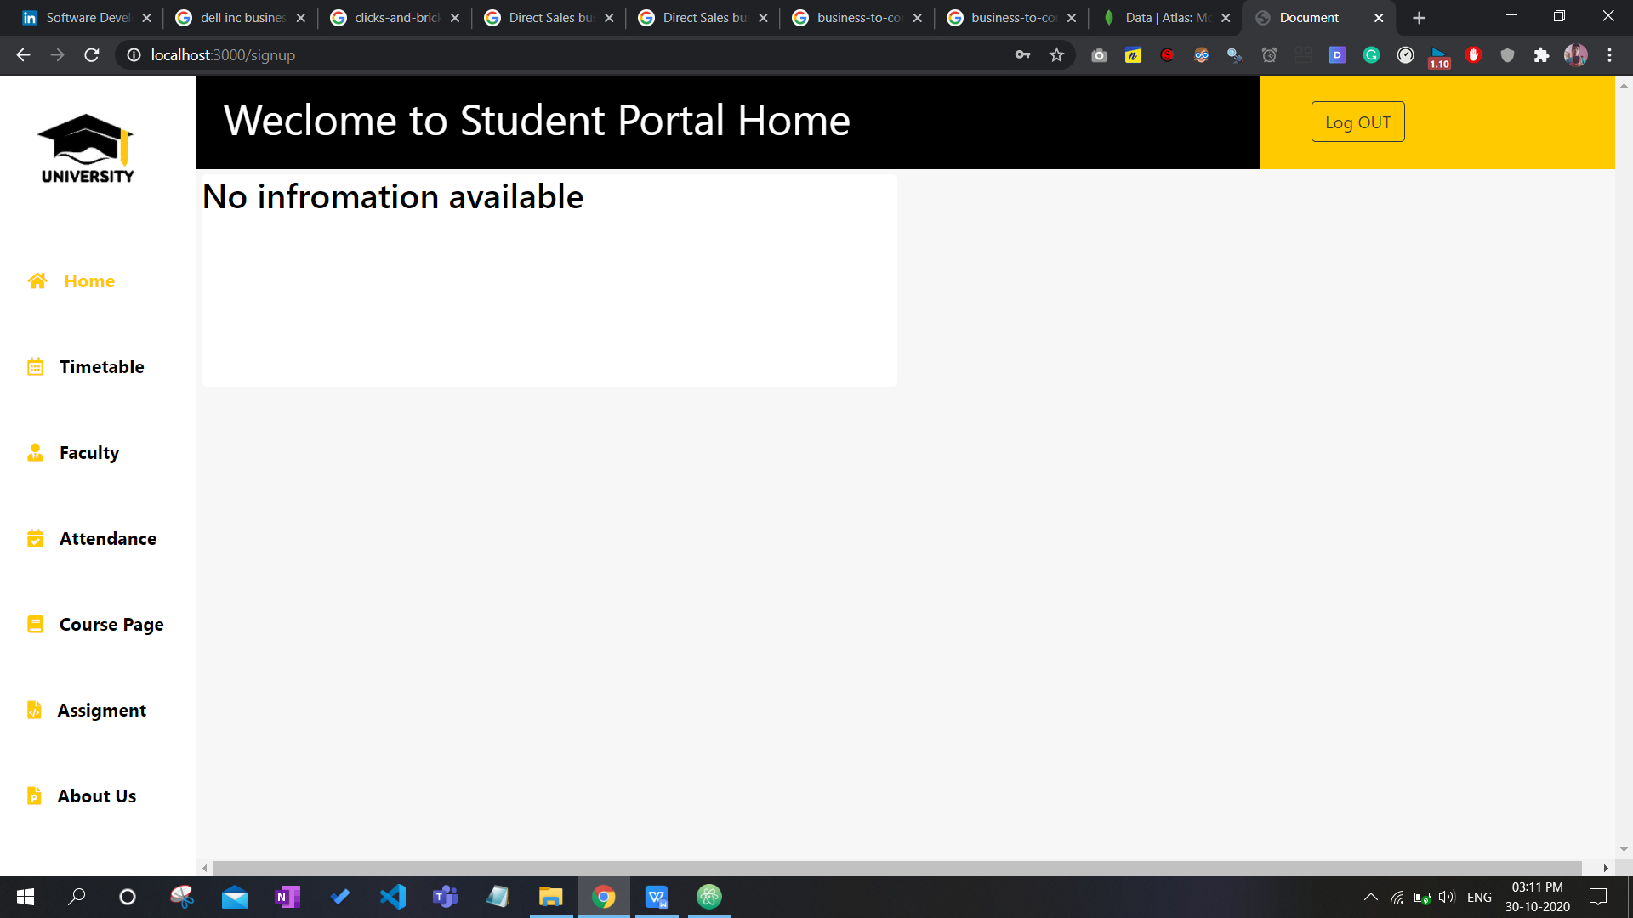

**Entering data for new user from teachers login-**

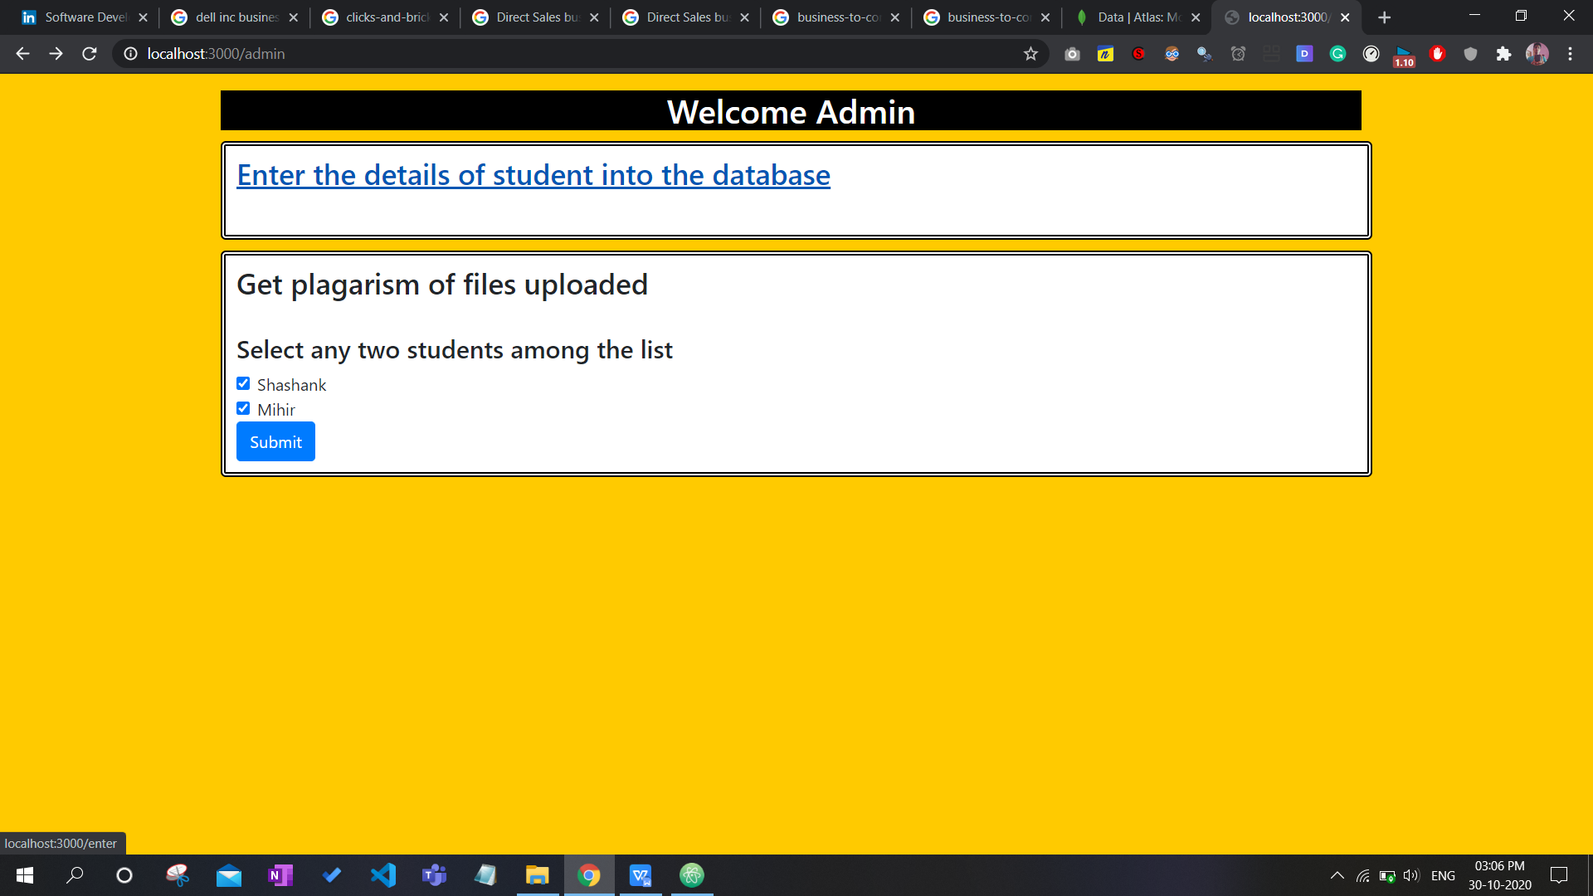

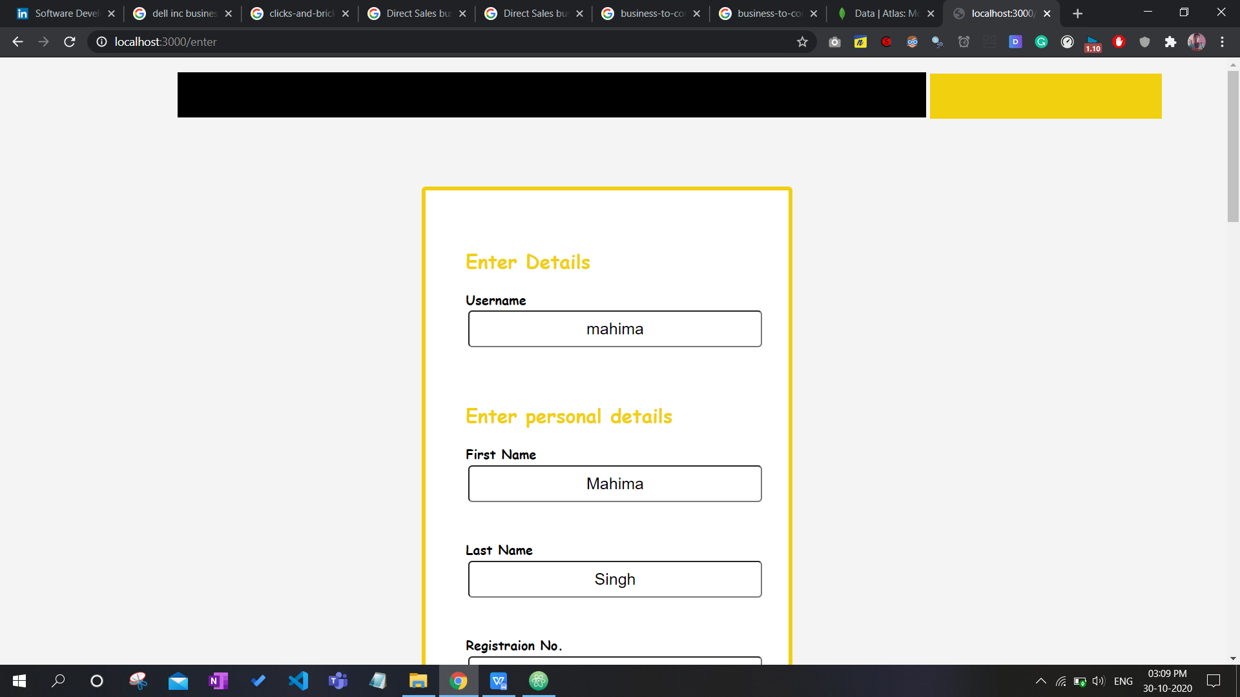

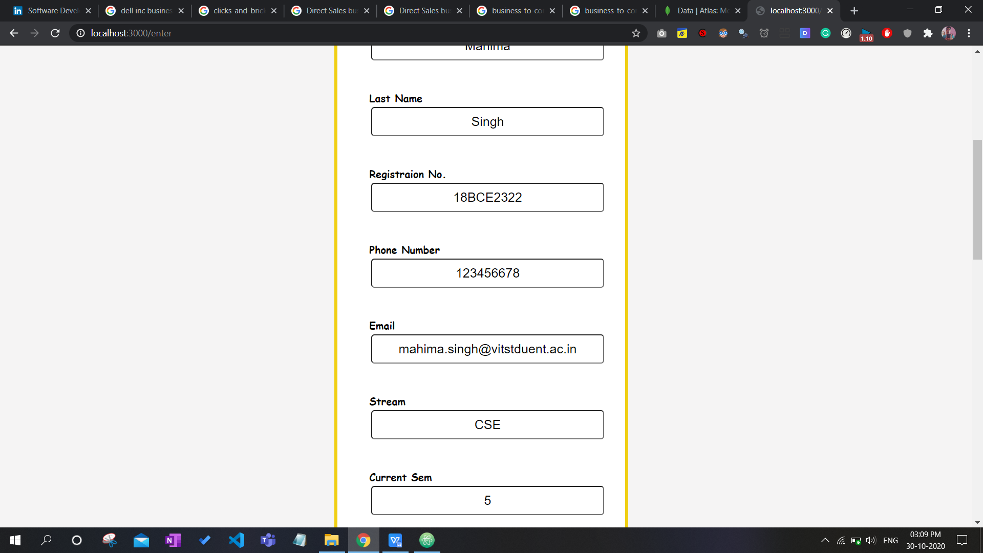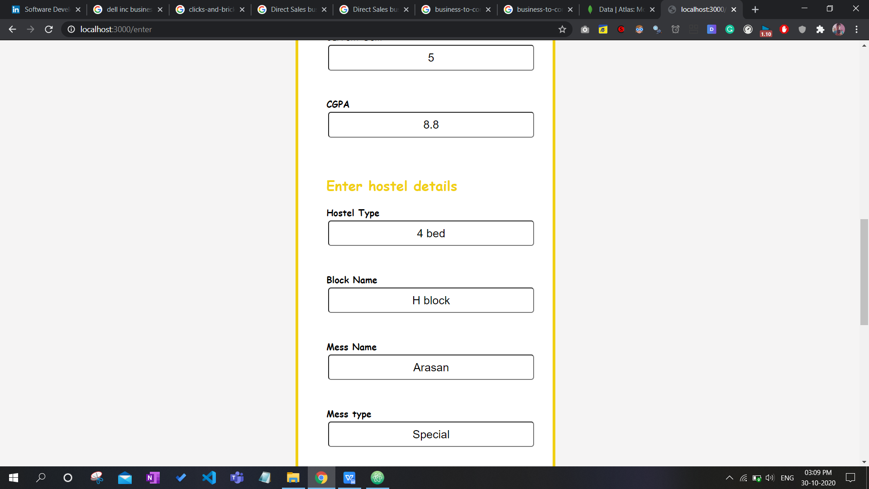

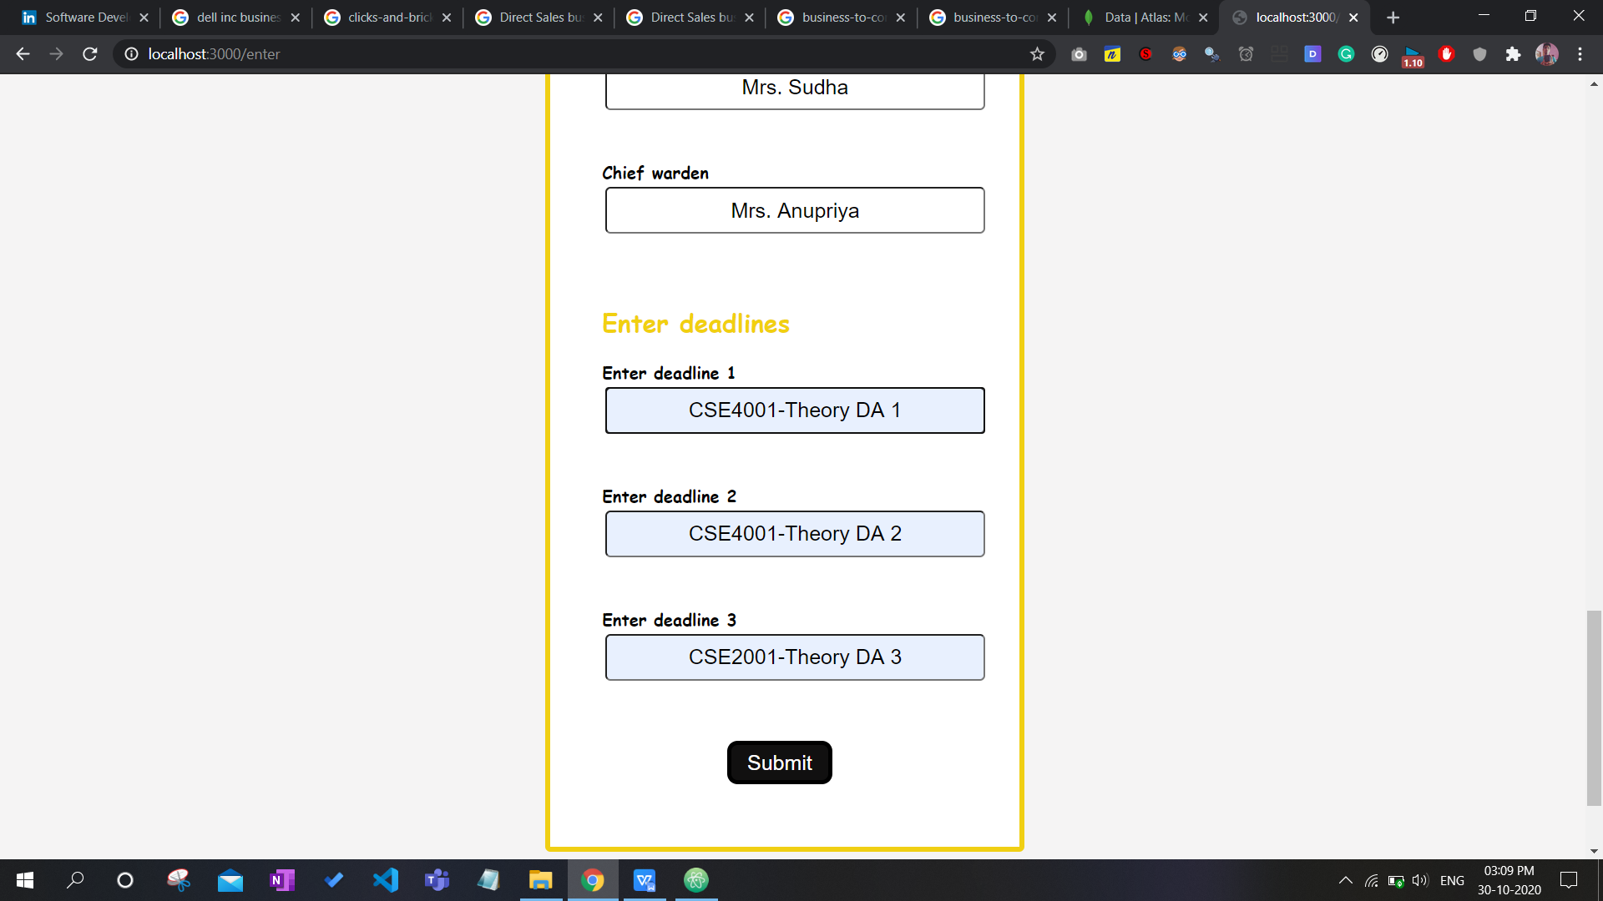

**Details are added dynamically into homepage-**

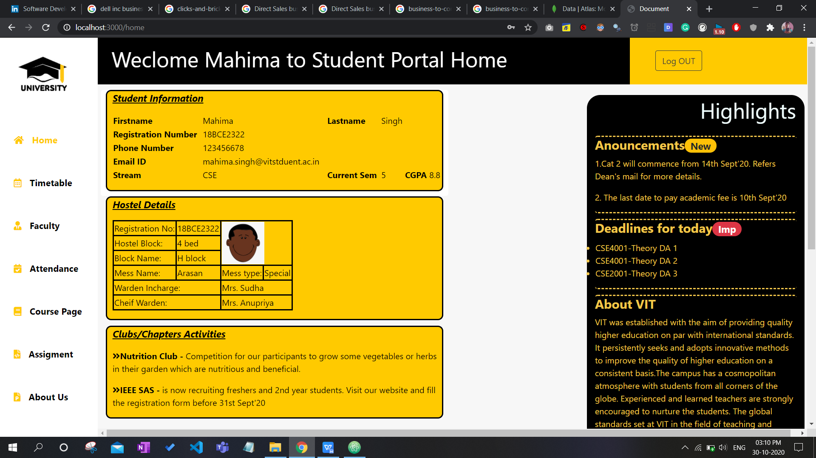

**Data added into the database successfully-**

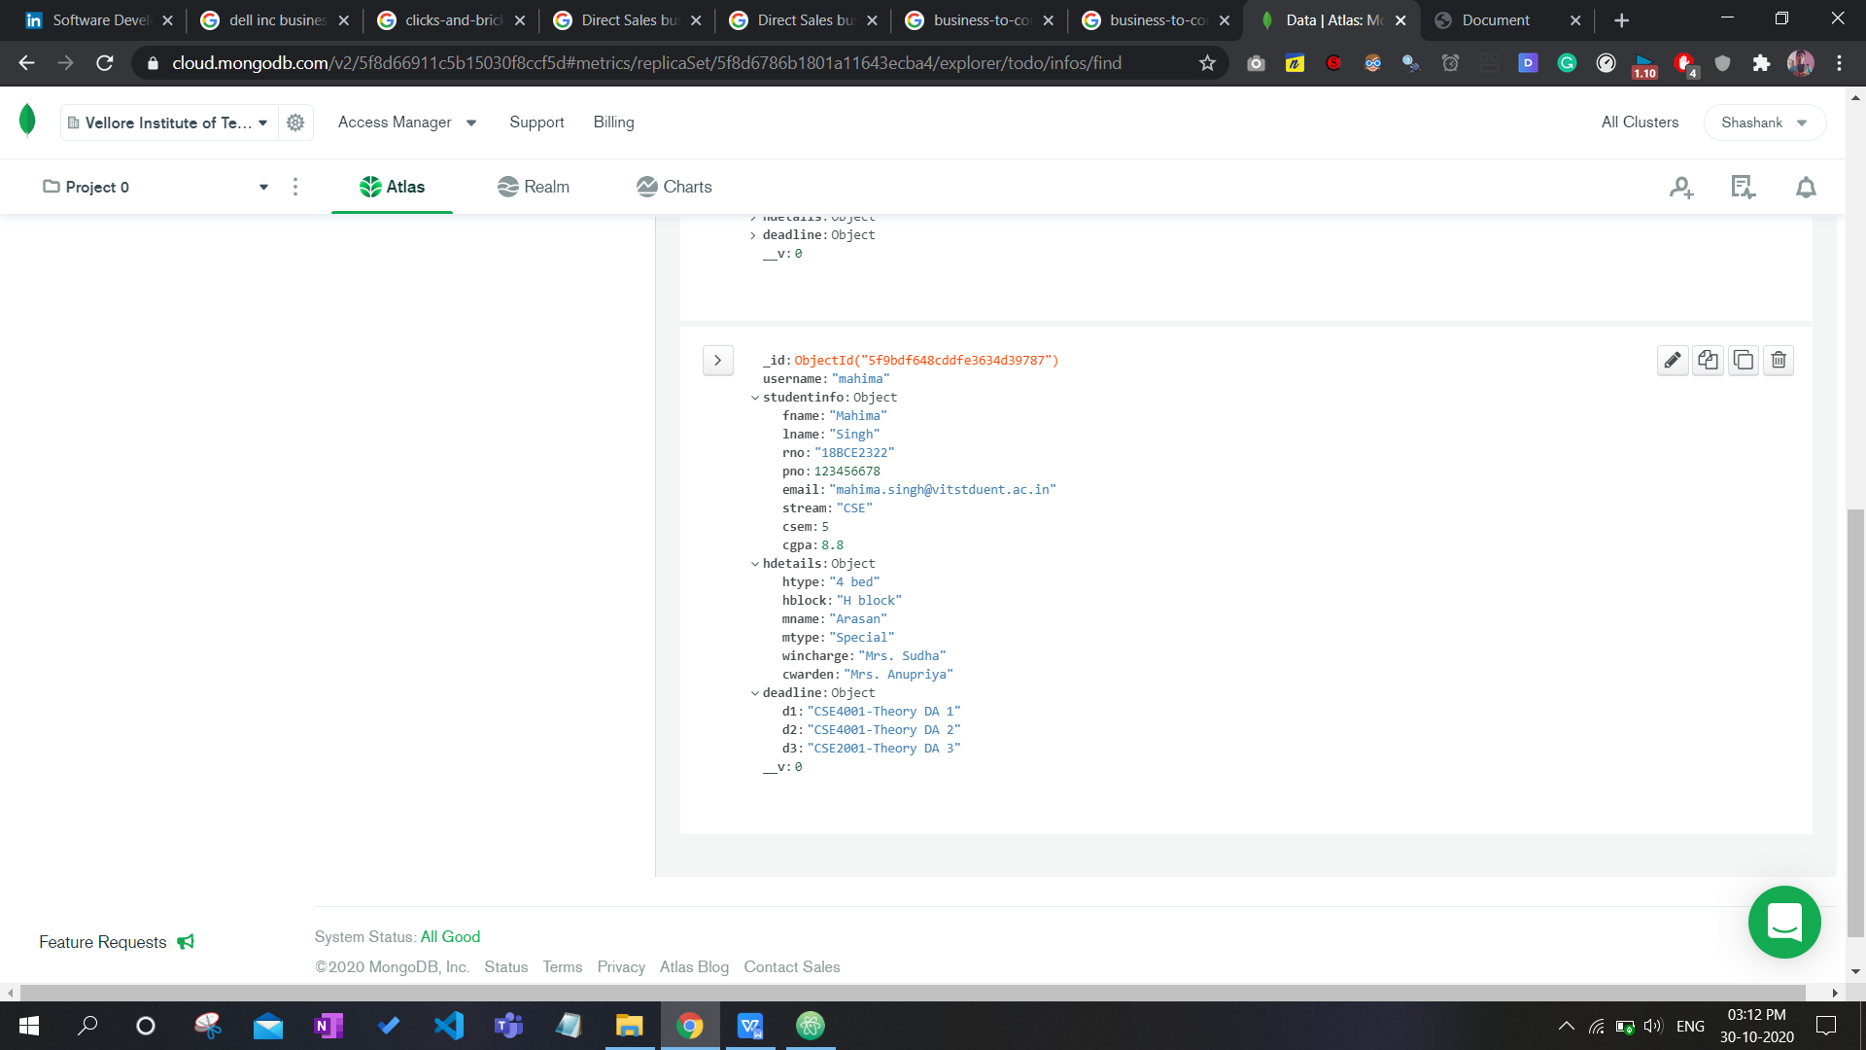

1. **CONCLUSION /FUTURE WORK**

It is an advantage for the consumers whose considerable time and energy is maintained, for the authority of the affected educational college whose workload is significantly reduced, whose facilities are shielded from misuse.

This system will also be used to view the full syllabus/course material, update the user's information(only by the faculty). Using this site will dramatically minimise the sharing of engineering document time.

The teacher will be able to check the novelty of the work uploaded by the student using the plagiarism checker.

This project 's concept is to get rid of the manual method and create a

Paperless labour. It can be remotely monitored and managed. This decreases the human power needed and provides reliable data. Details can be stored and accessed at any time. So, it's easier to have a framework based on the Internet. The required information can be obtained without delay by all stakeholders, faculty and management. In colleges and universities, this system is quite essential, useful and mandatory.

**Future Work:**

We plan to extend the portal for parents as well, so that they can keep a track of their child’s academics status. We thus plan to introduce a parent login as well.

We aim to extend this facility for the hostel staff as well so that the portal can be used for applying and approving leaves etc.

Apart from the academic facilities we aim to extend the project to allow transfer of fees, to keep a record of the receipts and any other outstanding dues.

1. **REFERENCES**
2. Raut, P. M. M. R., Lokhande, T. P., Godbole, K. D., More, S. J., Hatmode, S. S., & Tibude, N. D. (2019). PCE Staff/Student Portal. *International Journal of Computer Science Trends and Technology (IJCST)*, *7*(1), 1–6. <http://www.ijcstjournal.org/volume-7/issue-1/IJCST-V7I1P4.pdf>
3. Rajkumar, S., Tanwar, A., Malav, S., & Shreyash, P. (2017). Online College Portal. *International Research Journal of Engineering and Technology (IRJET)*, *4*(1), 1–3. https://www.irjet.net/archives/V4/i1/IRJET-V4I1315.pdf
4. <https://www.mongodb.com/what-is> mongodb#:~:text=MongoDB%20is%20a%20document%20database,and%20indexing%20that%20you%20need.
5. J. Kittivaraporn, J. Chokdeeanan, T. Yaophrukchai and T. T. Sunetnanta, "HRM portal: Human resource management portal," 2014 Third ICT International Student Project Conference (ICT-ISPC), Nakhon Pathom, 2014, pp. 183-186, doi: 10.1109/ICT-ISPC.2014.6923246.
6. W. G. S. Parwita, I. G. A. A. D. Indradewi and I. N. S. W. Wijaya, "String Matching based Plagiarism Detection for Document in Bahasa Indonesia," 2019 5th International Conference on New Media Studies (CONMEDIA), Bali, Indonesia, 2019, pp. 54-58, doi: 10.1109/CONMEDIA46929.2019.8981821.